**Description of the Enigma Machines**

**by**

**Tom Cuff, Frederick Community College (FCC), CIS208, Spring 2013**

Table of Contents

(Hint: Ctrl + left-click on the page number to immediately go to the start of that section.)

1 - Introduction 1

2 - Functional Description of the Encryption and Decryption Process 33

3 - Top-Level Description of the Software Used to Simulate an Enigma Machine 34

4 - How to Test the Software Used to Simulate an Enigma Machine 46

5 - Breaking the Enigma Machine Cipher – If it can be done 52

6 – Implementing an Enigma Machine on an Arduino Platform 57

Appendix A – Inter-Library Loan (ILL) at FCC 68

# 1 - Introduction

We are required for CIS208 (Spring 2013)Team Project to either create software version of an Enigma machine to encode plaintext or a software version of the Polish Bombe used to decipher the Enigma ciphertext. No matter which choice we make, we need to have a good understanding of how Enigma machines function. To this end, I have decided to canvass the literature on these machines and give an overview of their construction and function.

There are numerous books on the subject cryptology, which also contains descriptions of the various types and configurations of Enigma machines.[1] All Enigma machines perform a substitution encryption in which a given letter of plaintext is replaced with different letter of the Roman alphabet in the ciphertext.[2] If each letter of the plaintext was replaced with single letter in the ciphertext, then we would have what is known as a mono-alphabetic substitution cipher, e.g.,

Plaintext Letters : ABCDEFGHIJKLMNOPQRSTUVWXYZ

Ciphertext Letters: KSGJTDAYOBXHEPWMIQCVNRFZUL

In the above example, the plaintext letter C is always replaced with the letter G in the ciphertext. For example, the plaintext word ‘FOOD’ would be rendered as ‘DWWJ’ in the ciphertext. In contrast, the Enigma machines employed a poly-alphabetic cipher, wherein a given letter in the plaintext was substituted by more than one letter in the ciphertext.[3] For example, in the case of a certain setting of the rotors of the Enigma machine, the plaintext word ‘FOOD’ would be rendered as HYWI in the ciphertext. In other words, each time the same keyboard key of a particular plaintext letter was pressed on the Enigma machine a different letter would appear as the ciphertext letter in the lighted display.

Physically, the various Enigma machines all had the following subsystems: 1) a 26 letter keyboard for input, 2) a 26 letter, individually lighted display for output, 3) a plug board consisting of 26 pairs of jacks, 4) three (3) or more stepping rotors, and 5) a non-stepping, half-rotor known as a reflector. The following figure gives a very crude schematic representation of a Engima machine with a single static rotor, (E), three (3) stepping rotors (N, M & L) and a reflector (R).

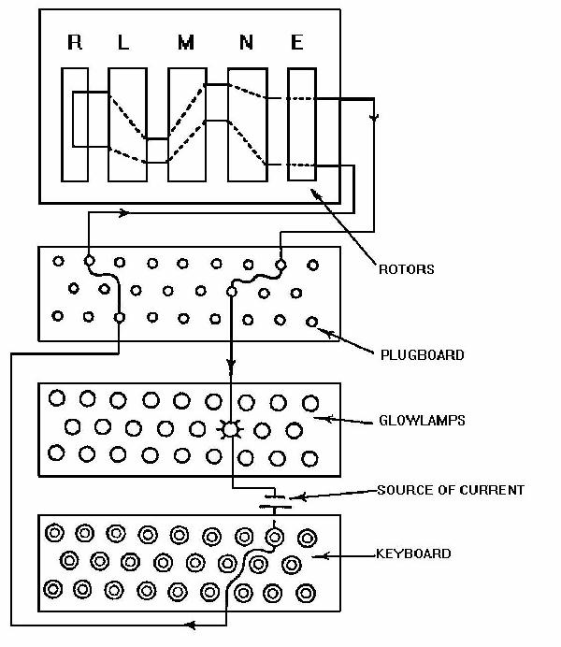

**FIGURE 1-1a – Schematic Representation of an Enigma Machine. Note, this is a very crude representation of the internal circuitry, and it does not covey the true complexity of the actual wiring. (Source:** [**http://faculty.gvsu.edu/aboufade/web/enigma/images/diagram.jpg**](http://faculty.gvsu.edu/aboufade/web/enigma/images/diagram.jpg) **.)**

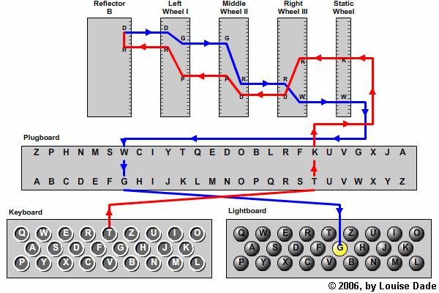

**FIGURE 1-1b – A Slightly More Detailed Schematic Diagram of a Three (3) Rotor Enigma Machine. Note, this is also a very crude representation of the internal circuitry, and it does not covey the true complexity of the actual wiring. (Source:** [**http://enigma.louisedade.co.uk/howitworks.html**](http://enigma.louisedade.co.uk/howitworks.html) **.)**

Figs.1a & 1b do not, however, convey the true complexity of the wiring of the Enigma machine. For example, in Fig. 1b it is shown how the ‘T’ key is mapped to the ‘G’ light. However, what is not shown is how the ‘G’ key is mapped to the ‘T’ light. In other words, since the Enigma machine is self-inverting, i.e., T → G and G →T, pressing the ‘G’ key should light the ‘T’ bulb, but this means that the ‘G’ key must connect to the G terminal on the plug board, which is already connected, as depicted in Fig. 1b, to the ‘G’ light. In other words, pressing the ‘G’ key should light both the ‘G’ bulb and the ‘T’ bulb. How does the Enigma machine prevent this from happening? The answer to this question can be found in Fig. 1c, which shows the actual wiring of a keyboard key in an Enigma machine.

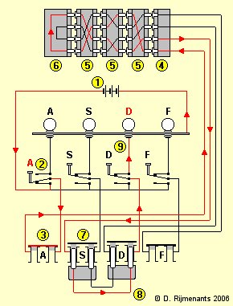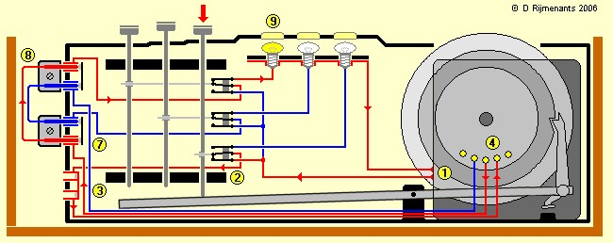

**FIGURE 1-1c - Two Detailed Views of the Actual Wiring of an Enigma Machine. [TOP]: Detailed view showing the wiring of the keys of the keyboard and the plug board. [BOTTOM]: Detailed view showing the wiring of the keys of the keyboard and plug board together with the mechanical connection to the keyboard keys. (Source:** [**http://users.telenet.be/d.rijmenants/en/enigmatech.htm**](http://users.telenet.be/d.rijmenants/en/enigmatech.htm) **.)**

Fig. 1c resolves the question about how pressing key does not light two of the bulbs simultaneously. Each key is connected to a SPDT (Single Pole Double Throw) switch that disconnects the light corresponding to the key being pressed, and then completes the common path to all the bulbs. …

Let us now consider each of the five (5) subsystems, in turn. The input subsystem, the keyboard, consists of only 26 keys, one for each capital (uppercase) letter of the alphabet. It is interesting what is not included in keyboard: 1) lowercase letters, 2) decimal digits (0-9), 3) a space bar or key, and 4) punctuation marks.[4] Likewise with respect to the output system, the 26 individually lit letters, there are only capital letters represented. The following figures depicts an Enigma machine with its keyboard, lighted display, three (3) stepping rotors, and plug board clearly visible; the reflector rotor is under the top cover and is not visible. The cover or lid of the Engima housing contains ten (10) spare incandescent light bulbs (a.k.a., glow bulbs), two (2) spare patch cords for the plug board, and written instructions in German on how to use the machine.

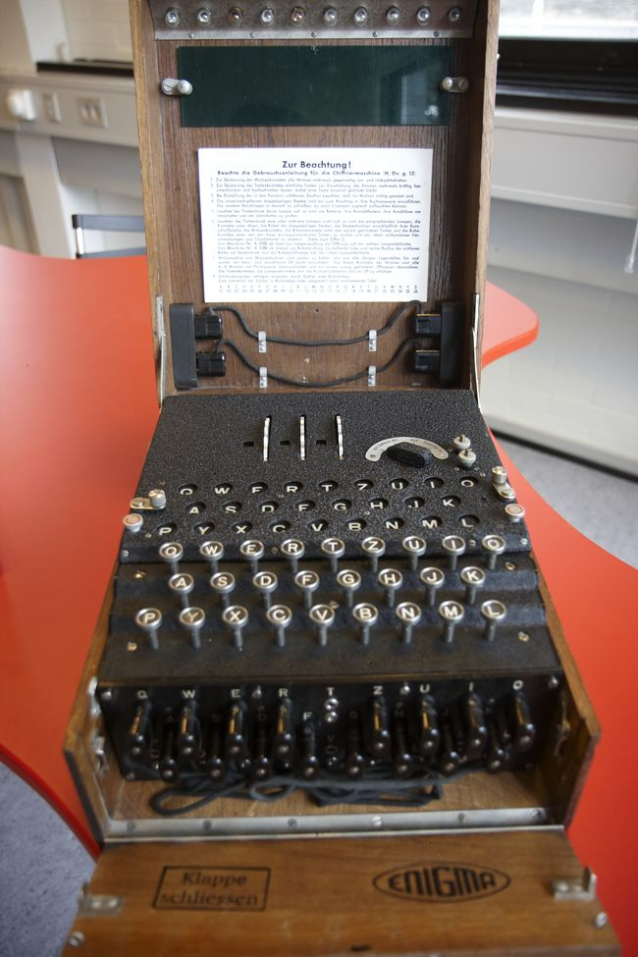

**FIGURE 1-2a- A Three (3) Rotor Enigma Machine. Note the power selector switch to the right of the three (3) rotors and to the immediate left of the pair of battery terminals. (Source: Technical University of Denmark,** [**http://www.matematiksider.dk/enigma_dtu_eng.html**](http://www.matematiksider.dk/enigma_dtu_eng.html) **.)**

The absence of number, space, and punctuation keys on the Enigma keyboard give a hint as to how messages were sent to and from it. The letters of the plaintext and ciphertext were run together in groups of five (5). Various sources have corroborated this idea that the ciphertext was sent in fixed-size groups of letters.[5] In other words, suppose you wished to transmit the following plaintext message: “The quick brown fox jumped over the lazy dog”. This sentence would be written out as follows: [6]

THEQU ICKBR OWNFO XJUMP EDOVE RTHEL AZYDO GXYZW

Note the use of nonsense letters, XYZW, in the last group of five letters to fill out the otherwise empty spaces. By employing fixed-size letter groups, no hint was given to people trying to break the code about the presence of one, two or three letter words, which would have made the task breaking the code somewhat easier. As we shall later in this introduction when we discuss the US Patent for the commercial version of the Enigma machine, there is an even more fundamental reason for employing a fixed grouping of the letters.

These five letter groups would then be submitted to the Enigma operator for encryption into, again, five letter groups. The encrypted five letter groups would then be sent via radio using Morse code. The use of radio to communicate messages to people in the field was the reason why encryption was necessary since anyone with a radio receiver could intercept the transmission. At the receiving end, the radio operator would transcribe the five letters groups representing the encrypted message and then give them to the Enigma operator to be decrypted into five letter groups, which, finally, would be read by someone who would organized the letters into variable length groups representing words in the language in use.

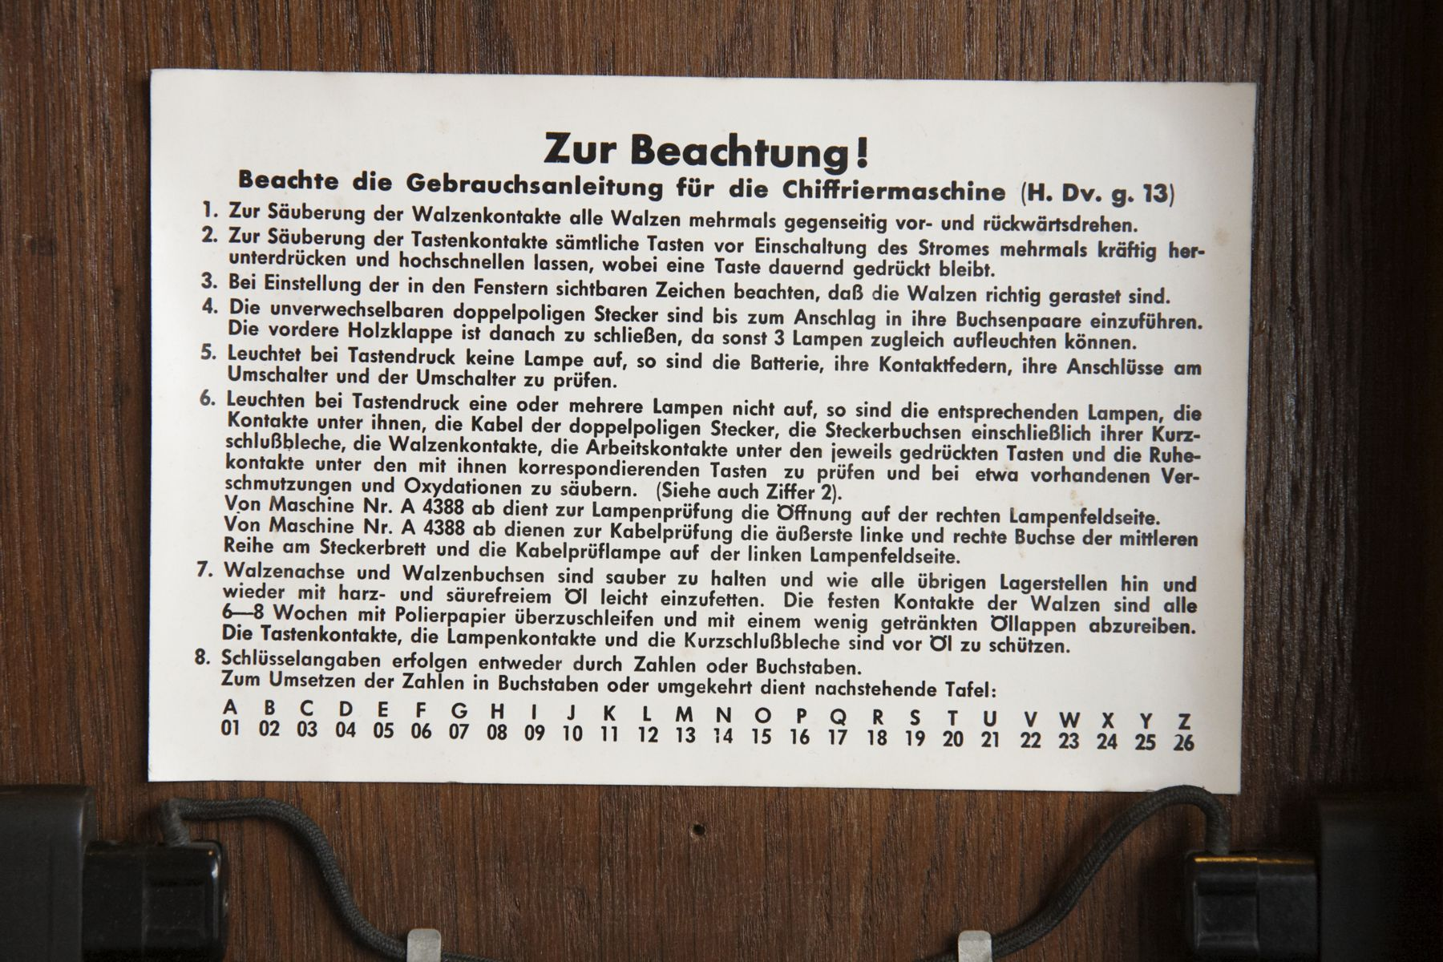

**FIGURE 1-2b- The Operating Instructions of an Enigma Machine (Source: Technical University of Denmark,** [**http://www.matematiksider.dk/enigma_dtu_eng.html**](http://www.matematiksider.dk/enigma_dtu_eng.html) **.).**

The following is my rough and ready translation of the German language operating instruction into English:

For Your Consideration!

Operating Instructions for the Cipher Machine (.. [H. Dv. g. 13])

1. To cleanse the rotor contacts of all rotors, repeatedly rotate them against one another in the forward and reverse direction.
2. To cleanse the keyboard contacts of all the keys before switching on the current repeatedly, forcefully press down and release upwards, whereby a key continues to remain pressed.
3. At the beginning observe that the number is visible in the window, so that the rotors are properly notched/registered.
4. The distinctive double pronged plug is be pushed into its electrical socket until it stops.
5. If during the pressing of a key no lamp lights, then the batteries, its spring contacts, its cable at the switch and the switch are to be tested.
6. If one or more of the lights do not light at a key press, then the aforementioned lamps, the contacts under them, the cable of the double pronged plugs, the plug sockets …, rotor contacts, the working contacts under the respective pressed key, and the resting contacts … are to be tested, and there about observed dirt and oxidation is to be removed. (See also Step #2, above).
7. Rotor studs and rotor sockets are to be cleaned and as … The solid contacts of the rotors are …
8. The key code follows either through numbers or letters.

A B C D E F G H I J K L M N O P Q R S T U V W X Y Z

01 02 03 04 05 06 07 08 09 10 11 12 13 14 15 16 17 18 19 20 21 22 23 24 25 26

The plug board, situated on the front of the Enigma machine, is used to further complicate the encryption.

The more important complicating feature, however, was the attachment of a plugboard. It was this that distinguished the military from the commercial Enigma, and made it something that had unnerved the British analysts. It had the effect of performing automatically an extra swapping of the letters, both before entering the rotators, and after emerging from them. Technically, this was achieved by attaching wires, with plugs at each end, into a plugboard with 26 holes – rather like making connections on a telephone switchboard. It required ingenious electrical connections, and the use of double wires, to have the required effect. Until late 1938, it was usual in the German use of the machine to have only six or seven pairs of letters connected in this way. [Hodges 1983, p. 169]

The above block quotation is incomplete in one vital respect, the plug board did not consist of “… 26 hole …”, rather, it consisted of 26 pairs of holes. The reason why there had to be a pairs of holes for each letter is that, like the switchboard in a telephone exchange, the cable connecting various jacks has two wires in it, one going to the tip of the plug and one going to the ring of the plug with the tip and ring insulated from one another..

The patch cords for the plug board employed a cable with two, insulated wires in it: one wire going to upper portion and one to the lower portion of the jack pair. As the following figure shows quite clearly, each pair of jacks consists of large jack above a small jack. This size asymmetry was needed in order to prevent the operator from inserting the plug upside down effectively crossing the wires of the patch cord cable, i.e., the size asymmetry served as a ‘key’ for the connector thus ensuring proper mating.

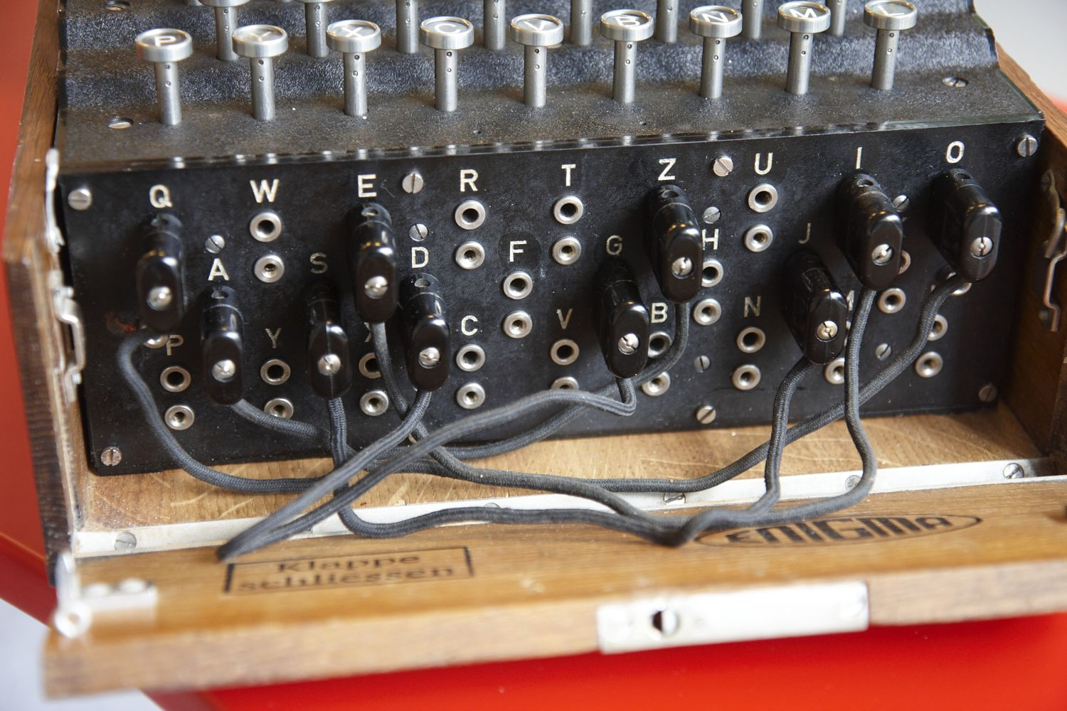

**FIGURE 1-2c – The Plug Board of an Enigma Machine (Source: Technical University of Denmark,** [**http://www.matematiksider.dk/enigma_dtu_eng.html**](http://www.matematiksider.dk/enigma_dtu_eng.html) **.).**

Figs. 1a & 1b purport to explain how the plug board is wired into the Enigma machine, but they are of little value in this respect. For example, if no patch cords are plugged into the plug board, how can keyboard and the light panel still be connected to the rotors? The answer to this question can be found in Fig. 1c, which for convenience sake has been duplicated below. Fig. 1c reveals that the dual jacks in the plug board are normally internally short-circuited, i.e., when the corresponding plug-pair is not inserted, the jack-pair are connected together. Operationally, we know that only a few patch cords were used with the plug board. There is a second difficulty with the simple-minded wiring diagrams found in Figs. 1a & 1b, and this relates how the light in the light panel are connected as was mentioned earlier.



**FIGURE 1-1c [Duplicated from earlier in this document.] - Two Detailed Views of the Actual Wiring of an Enigma Machine. [TOP]: Detailed view showing the wiring of the keys of the keyboard and the plug board. [BOTTOM]: Detailed view showing the wiring of the keys of the keyboard and plug board together with the mechanical connection to the keyboard keys. (Source: http://users.telenet.be/d.rijmenants/en/enigmatech.htm.)**

According to the book by Konheim, the original, commercial version of the Engima was patented both in Germany and in the United States. Konheim indicates that the US Patent had the number 1,657,411 with the US Patent filed on February 6, 1923 and granted on January 24, 1928.[7] Fig. 2e contains the drawings from the first sheet of US Patent No. 1,657,411. [8] The commercial version of the Enigma machine revealed in the US Patent differs from the military version employed by the German military during WWII in the following ways: 1) the commercial machine had 4 stepping rotors instead of the 3 found in its military counterpart; 2) the commercial machine did not have a half-rotor (a.k.a., reflector) like the military version, and 3) the commercial machine did not employ the plug board used in the military machine. There are other differences between the commercial and military versions of the Enigma machine, which will be discussed later.

In the text of the US Patent, the inventor Arthur Scherbius mentions that these types of encryption machines had a very serious defect, see the excerpt below from page 2( sheet 1) of the US Patent,

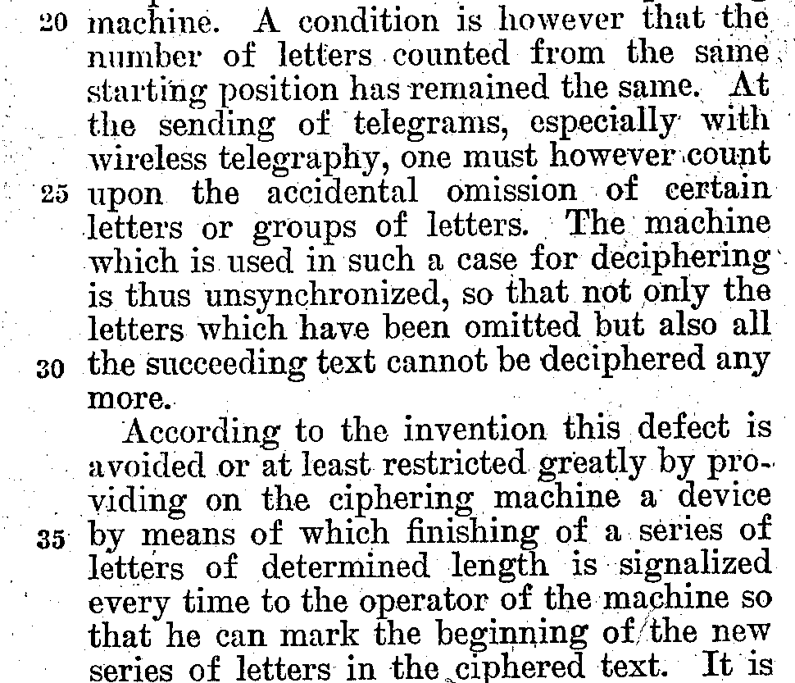

The inventor indicates in the US Patent a counter could be added to the cipher machine so that, for example, a bell might ding to indicate that a predetermined number of characters had by enciphered. As an aid to detecting missing characters the inventor makes the following suggestion on page 4 (sheet 3) of the US Patent,

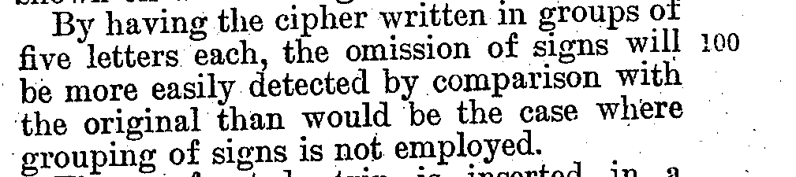

As was mentioned earlier, there are other differences between the commercial and military versions of the Enigma machines, and it would helpful to review them before moving on. There are apparently two (2) other modifications to the Enigma machine that can further complicate the encryption: 1) the mapping of the static/fixed rotor, and 2) the disposition (moving or static) of the half-rotor known as the reflector. As Hodges mentions in his biography of Alan Turing,

Highly ingenious observations, good guessing, and the use of elementary group theory, produced the rotor wirings, and the structure of the reflector. The guessing, as it happened, was necessary to ascertain how the letters on the keyboard were connected to the enciphering mechanism. They might have been connected in some jumbled order to introduce another element of complexity into the machine. But they [the Poles] guessed and verified that the Enigma design made no use of this potential freedom. The letters joined to the rotor in alphabetic order. [Hodges 1983, p. 170]

The book Shachtman also mentions this breakthrough by the Poles,[9]

One problem that he [Marian Rejewski] had already solved had to do with the keyboard. He had first assumed that since the Enigma had a QWERTYU keyboard (as did all typewriters) the letter Q would be connected with position #1 in the enciphering unit. After many failures based on that assumption, Rejewski figured out that literal-minded Germans had not Q to position #1 but to position #17, because Q was the seventeenth letter in the alphabet. W was connected to [position] #23, E to #5, and so on. Once Rejewski had made this imaginative jump, decryption proved easier. [Shachtman 2002, pp. 58-59]

Shachtman description is okay except for one flaw, the German Enigma does not employ a QWERTYU keyboard but rather a QWERTZU keyboard, see Fig. 2A. On a QWERTYU keyboard, the order of the letters is as follows: QWERTYUIOPASDFGHJKLZXCVBNM, while on a QWERTZU keyboard, the order of the letters is as follows: QWERTZUIOASDFGHJKPYXCVBNML. In order to make it easier to see the differences between the two keyboard configurations, they are shown below, one below the other:

QWERTYU keyboard: QWERTYUIOPASDFGHJKLZXCVBNM – American keyboard

QWERTZU keyboard: QWERTZUIOASDFGHJKPYXCVBNML – Enigma keyboard

It should be noted that the German Railway (Rocket) Enigma machine, that was introduced on February 7, 1941, employed a fixed rotor which uses the QWERTZU mapping instead of the identity mapping ABCDEFG. These are the two most obvious mappings for the fixed rotor: 1) according to the letter’s position on the keyboard, and 2) according to the letter’s position in the alphabet.

While the original commercial and military versions of the Enigma machine did not scramble the alphabetic order at connection between the keyboard and the fixed rotor, i.e., these machines used the identity mapping, this was not true for all Enigma machines as mentioned in the previous paragraph. For example, the German Railway (Rocket) Enigma machines, introduced on February 7, 1941, did not employ the identity mapping, and it is this particular type of Enigma machine that we are supposed to simulate for our Team Project,

START OF EXCERPT (<http://en.wikipedia.org/wiki/Enigma_rotor_details> )

**Terminology**

* *The reflector is also known as the reversing drum or, from the German, the Umkehrwalze or UKW.*

|  |  |  |  |
| --- | --- | --- | --- |
| **Rotor Wiring** | | | |
| **Rotor #** | **ABCDEFGHIJKLMNOPQRSTUVWXYZ** | **Date Introduced** | **Model Name & Number** |
| I*C* | DMTWSILRUYQNKFEJCAZBPGXOHV | 1924 | [Commercial Enigma](http://en.wikipedia.org/w/index.php?title=Commercial_Enigma&action=edit&redlink=1) A, B |
| II*C* | HQZGPJTMOBLNCIFDYAWVEUSRKX | 1924 | Commercial Enigma A, B |
| III*C* | UQNTLSZFMREHDPXKIBVYGJCWOA | 1924 | Commercial Enigma A, B |
|  |  |  |  |
| **Rotor #** | **ABCDEFGHIJKLMNOPQRSTUVWXYZ** | **Date Introduced** | **Model Name & Number** |
| I | JGDQOXUSCAMIFRVTPNEWKBLZYH | 7 February 1941 | German Railway (Rocket) |
| II | NTZPSFBOKMWRCJDIVLAEYUXHGQ | 7 February 1941 | German Railway (Rocket) |
| III | JVIUBHTCDYAKEQZPOSGXNRMWFL | 7 February 1941 | German Railway (Rocket) |
| UKW | QYHOGNECVPUZTFDJAXWMKISRBL | 7 February 1941 | German Railway (Rocket) |
| ETW | QWERTZUIOASDFGHJKPYXCVBNML | 7 February 1941 | German Railway (Rocket) |
|  |  |  |  |
| **Rotor #** | **ABCDEFGHIJKLMNOPQRSTUVWXYZ** | **Date Introduced** | **Model Name & Number** |
| I-*K* | PEZUOHXSCVFMTBGLRINQJWAYDK | February 1939 | Swiss K |
| II-*K* | ZOUESYDKFWPCIQXHMVBLGNJRAT | February 1939 | Swiss K |
| III-*K* | EHRVXGAOBQUSIMZFLYNWKTPDJC | February 1939 | Swiss K |
| UKW-*K* | IMETCGFRAYSQBZXWLHKDVUPOJN | February 1939 | Swiss K |
| ETW-*K* | QWERTZUIOASDFGHJKPYXCVBNML | February 1939 | Swiss K |
|  |  |  |  |
| **Rotor #** | **ABCDEFGHIJKLMNOPQRSTUVWXYZ** | **Date Introduced** | **Model Name & Number** |
| I | EKMFLGDQVZNTOWYHXUSPAIBRCJ | 1930 | [Enigma I](http://en.wikipedia.org/w/index.php?title=Enigma_I&action=edit&redlink=1) |
| II | AJDKSIRUXBLHWTMCQGZNPYFVOE | 1930 | Enigma I |
| III | BDFHJLCPRTXVZNYEIWGAKMUSQO | 1930 | Enigma I |
| IV | ESOVPZJAYQUIRHXLNFTGKDCMWB | DEC 1938 | M3 Army |
| V | VZBRGITYUPSDNHLXAWMJQOFECK | DEC 1938 | M3 Army |
| VI | JPGVOUMFYQBENHZRDKASXLICTW | 1939 | M3 & M4 Naval (FEB 1942) |
| VII | NZJHGRCXMYSWBOUFAIVLPEKQDT | 1939 | M3 & M4 Naval (FEB 1942) |
| VIII | FKQHTLXOCBJSPDZRAMEWNIUYGV | 1939 | M3 & M4 Naval (FEB 1942) |
|  |  |  |  |
| **Rotor #** | **ABCDEFGHIJKLMNOPQRSTUVWXYZ** | **Date Introduced** | **Model Name & Number** |
| Beta | LEYJVCNIXWPBQMDRTAKZGFUHOS | Spring 1941 | M4 R2 |
| Gamma | FSOKANUERHMBTIYCWLQPZXVGJD | Spring 1942 | M4 R2 |
| Reflector A | EJMZALYXVBWFCRQUONTSPIKHGD |  |  |
| Reflector B | YRUHQSLDPXNGOKMIEBFZCWVJAT |  |  |
| Reflector C | FVPJIAOYEDRZXWGCTKUQSBNMHL |  |  |
| Reflector B Thin | ENKQAUYWJICOPBLMDXZVFTHRGS | 1940 | M4 R1 (M3 + Thin) |
| Reflector C Thin | RDOBJNTKVEHMLFCWZAXGYIPSUQ | 1940 | M4 R1 (M3 + Thin) |
| ETW | ABCDEFGHIJKLMNOPQRSTUVWXYZ |  | Enigma I |

Technical comments related to Enigma modifications 1939-1945.

### [[edit](http://en.wikipedia.org/w/index.php?title=Enigma_rotor_details&action=edit&section=6)]Swiss K

* In 1941 it became known to the Swiss that some of their Enigma traffic was being read by the French. It was decided to make some design modifications.
* One of the modifications consisted in modifying the wheel stepping on the Swiss Army machine. The slow, left-hand wheel was made stationary during operation while the second wheel stepped with every key stroke.
* The third wheel and the UKW would step in the normal fashion with Enigma stepping for the third wheel.
* The stationary but rotatable left-hand wheel was meant to make up for the missing stecker connections on the commercial machine.
* *Swiss Army Enigma machines were the only machines modified. The surviving Swiss Air Force machines do not show any signs of modification. Machines used by the diplomatic service apparently were not altered either.*

## Turnover positions

In this table the turnover point of each rotor is listed. For more details on how the rotors move, please check the Stepping motionsection and the remarks on double-stepping in the [Enigma](http://en.wikipedia.org/wiki/Enigma_machine) article.

|  |  |  |
| --- | --- | --- |
| **Rotor** | **Notch** | **Effect** |
| I | Q | If rotor steps from Q to R, the next rotor is advanced |
| II | E | If rotor steps from E to F, the next rotor is advanced |
| III | V | If rotor steps from V to W, the next rotor is advanced |
| IV | J | If rotor steps from J to K, the next rotor is advanced |
| V | Z | If rotor steps from Z to A, the next rotor is advanced |
| VI, VII, VIII | Z+M | if rotor steps from Z to A, or from M to N the next rotor is advanced |

END OF EXCERPT (<http://en.wikipedia.org/wiki/Enigma_rotor_details> )

There is only one problem with the above excerpt, and that has to do with notch positions. In particular, for the German Railway (Rocket) Enigma machine, a different website has the following table of stepping rotor mappings and notch positions, and the notch positions do not match those from the Wikipedia table.

START OF EXCERPT (<http://www.cryptomuseum.com/crypto/enigma/k/railway.htm>)

|  |  |
| --- | --- |
| **Wiring** |  |
|  | |
|  |  |

|  |
| --- |
| The table below shows the wiring for the standard Railway Enigma (Rocket I). Only wheels I, II and III were used. Note that the turnover notches are the same as on commercial [Enigma K](http://www.cryptomuseum.com/crypto/enigma/k/index.htm), but that the position of the notches of wheels I and III has been swapped. This swapping was relatively easy, as the notch (gap) is part of a [removable ring](http://www.cryptomuseum.com/crypto/enigma/img/300879/035/full.jpg) that is held in place by four bolts. |

|  |  |  |  |  |  |  |  |  |  |  |  |  |  |  |  |  |  |  |  |  |  |  |  |  |  |  |  |  |  |  |  |  |  |  |  |
| --- | --- | --- | --- | --- | --- | --- | --- | --- | --- | --- | --- | --- | --- | --- | --- | --- | --- | --- | --- | --- | --- | --- | --- | --- | --- | --- | --- | --- | --- | --- | --- | --- | --- | --- | --- |
| |  |  |  |  |  | | --- | --- | --- | --- | --- | | **Wheel** | **ABCDEFGHIJKLMNOPQRSTUVWXYZ** | **Notch** | **Turnover** | **#** | |  | | | | | | ETW | QWERTZUIOASDFGHJKPYXCVBNML |  |  |  | | I | JGDQOXUSCAMIFRVTPNEWKBLZYH | V | N | 1 | | II | NTZPSFBOKMWRCJDIVLAEYUXHGQ | M | E | 1 | | III | JVIUBHTCDYAKEQZPOSGXNRMWFL | G | Y | 1 | | UKW | QYHOGNECVPUZTFDJAXWMKISRBL |  |  |  | |

|  |
| --- |
|  |
|  |

|  |
| --- |
|  |
| **References** |  |
|  | |
|  |  |

|  |
| --- |
| 1. [David Hamer, Geoff Sullivan and Frode Weierud *Enigma Variations: An Extended Family of Machines*](http://cryptocellar.org/enigma/) Cryptologia, July 1998, Volume XXII, Number 3. |

END OF EXCERPT (<http://www.cryptomuseum.com/crypto/enigma/k/railway.htm>)

Another difference discovered between these two web sites is the fact that while the table on the Wikipedia site does not explicitly explain that the word “Rocket’, associated with the German Railway Enigma, is a key or traffic key, the Crypto Museum site, on the other hand, clearly indicates that there were actually three (3) keys to the German Railway Enigma: Rocket I, Rocket II, and Rocket III. What do these web sites mean by the term “key” or “traffic key”? The answer, like everything else having to do with Enigma, is complicated. Basically, though, the key or traffic key are the procedures for configuring the Enigma machine to be able to encrypt and decrypt communications.

Although the mappings (wirings) for the three (3) stepping rotors are *same* between the two websites for the German Railway Enigma, the notch positions are not the same, and, in addition, the Crypto Museum site makes the distinction between a notch position and a turnover position. What is the difference between a notch position and a turnover position? One place to look for an answer to this question is the 1998 *Cryptologia* paper by Hamer *et al.* referenced in the above excerpt.[10] The aforementioned paper also references an earlier *Cryptologia* paper by Hamer, which more closely examines the stepping behavior of the medium rotor.[11] The *Cryptologia* paper by Hamer *et al.* explains the difference between a notch position and a turnover position in the section of their paper on the German Railway Enigma,

START OF EXCERPT (p. 5 of the ‘enigvar2.pdf’ file.)



END OF EXCERPT (p. 5 of the ‘enigvar2.pdf’ file.)

The note under the table in the above excerpt indicates that the notch position corresponds to the notch’s location on the indicator ring of the rotor, while the turnover or window position corresponds to the letter appearing in the window of the front panel when the notch position is reached, i.e., there is an offset between the mechanism that detects the notch position and the window in the front panel of the Enigma machine. When we coded our Enigma simulator, we made the notch position and turnover or window position the same, which is an error.

The 1997 *Cryptologia* paper by Hamer mentions another even more obscure behavior of some Enigma machines, namely the double-stepping of the medium rotor. Depending on the type of Enigma machine, they have one of two distinct stepping behaviors for their stepping rotors. The stepping behavior most people are aware of is the odometer type of stepping motion, which Hamer calls cyclometric stepping. This is the stepping behavior that we have designed into our Enigma simulator. However, there are some Enigma machines that have a stepping behavior wherein the medium or middle rotor undergoes an extra step, called a double-step, due to the mechanics of the pawl, ratchet and notch mechanism The following excerpt from this paper, captured as a screenshot due to the properties of the document not allowing copying, shows the behavior in question,

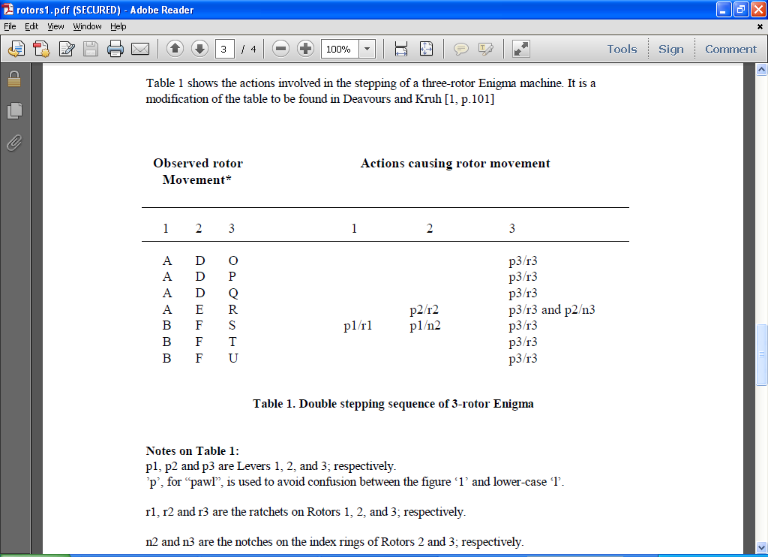

The first three columns of the above table list the key code seen through the windows in the front panel of an Enigma machine with the rightmost column, #3, being the fast rotor. The fast rotor has a notch in it , n3, that causes the medium rotor, #2, to step at the turnover position ‘Q’ going to ‘R’ of the fast rotor. The medium rotor, #2, has a notch in it, n2, that causes the slow rotor. #1, to step at the notch position of the medium rotor and causes the medium rotor to also step due to the pawl, p1, of the slow rotor engaging both the ratchet, r1, of the slow rotor as well as the notch, n2, of the medium rotor. Note, the fast rotor also engages in double stepping motion for the same reason the medium rotor does, but, in the case of the fast rotor, the double stepping motion is *invisible* because the rotor moves with each keystroke, anyway. The double stepping motion of the medium rotor is known as Enigma stepping to distinguish it from the default cyclometric stepping. Our Enigma simulator, of course, employs the default cyclometric stepping motion.

Of course, the main question we have to answer about cyclometric versus Enigma stepping is which Enigma machines have which type of stepping motion, in particular, does the German Railway Enigma utilize cyclometric or Enigma stepping? According to the 1998 *Cryptologia* paper by Hamer *et al.* most Enigma machines employed Enigma stepping,

START OF EXCERPT (p. 9 of the ‘enigvar.pdf’ file.)



END OF EXCERPT (p. 9 of the ‘enigvar.pdf’ file.)

As of 5/10/13, I still do not have a definitive answer to this question. Initially, I thought that reading the 1998 *Cryptologia* paper by Hamer *et al.,* wherein they enumerate many – but not all - of the different types of Enigma machines, would provide a clear answer. However, the article is not completely clear about the type of stepping used by the German Railway Enigma, as the following excerpts will attest,

START OF EXCERPTS (pp. 2 of the ‘enigvar.pdf’ file.)



END OF EXCERPT (pp. 2 of the ‘enigvar.pdf’ file.)

START OF EXCERPTS (pp. 2 & 3 of the ‘enigvar2.pdf’ file.)



END OF EXCERPT (pp. 2 & 3 of the ‘enigvar2.pdf’ file.)

The above excerpt does point out, however, another error in our knowledge about the Enigma machine we are supposed to be simulating, namely, that the reflector (Umkehrwalze or UKW) was settable, i.e., it could be rotated to any desired position as part of the setup configuration of the machine. In other words, the reflector would have had a serrated wheel poking through the front panel of the Enigma machine to allow the user to dial-in the position of the reflector in the same way that the initial positions of the three stepping rotors were dialed-in via their respective serrated wheels in the front panel. The following excerpt, also from the 1998 *Cryptologia* paper by Hamer *et al.,* explains the difference between a settable and moving reflector,

START OF EXCERPT (p. 2 of the ‘enigvar2.pdf’ file.)



END OF EXCERPT (p. 2 of the ‘enigvar2.pdf’ file.)

The ‘heart’ of both the commercial and military Enigma machines is the group of stepping routers. For the purposes of illustration, we shall only consider the military Enigma machine with its three (3) stepping rotors. These rotors, which have 26 positions corresponding to the letters of the Roman alphabet, are geared so that they rotate as do the wheels of a odometer, i.e., each full rotation of the slow rotor requires 26 full rotations of the medium rotor, while each full rotation of the medium rotor requires 26 full rotations of the fast rotor. From Fig. 2e, it is obvious that the fast rotor is the rightmost rotor since it is driven by the smallest gear (17) compared to gear (16). This arrangement is exactly what is found in an odometer. The miles wheel is the rightmost wheel, the tens of miles wheel is the middle wheel, and the hundreds of miles wheel is at the far left. The miles wheel rotates the fastest, followed by the tens of miles wheel, and the hundreds of miles wheel rotates slowest. Let us suppose that the three (3) odometer wheels are initially all set to 0: 100’s of miles wheel = 0, the 10’s of miles wheel = 0, and the miles wheel = 0. As the miles wheel rotates to higher miles, eventually it gets to mile 9, and then in the transition from mile 9 to mile 0, the 10’s of miles wheel rotates from the 0 position to the 1 position. This explanation is basically the same one offered up by Hodges in his biography of Alan Turing,

They [the stepping rotors] were geared essentially* like any kind of adding machine or comptometer, so that the middle rotor would move on one step when the first had made a complete revolution, and the innermost move a step when the middle one had made a complete turn. The ‘reflector’, however, would not move, it being a fixed set of wires connecting the outputs of the innermost rotor.

*There were complications, but not affecting the account that follows. [Hodges 1983, p. 167]

Of course, the “complications” that Hodges mentions but dismisses are essential for anyone trying to build a simulator of the Enigma machine.

In class on Tuesday, 2/12/13, one of the students (Chris) mentioned that, in response to the pressing of a key on the keyboard, the fast stepping rotor moves first and then the light lights on the display, i.e., this is similar to the difference between the pre-increment, ++i, and post-increment, i++, operations in Java and C++. This is an important fact about the operation of the Enigma machine, which is rarely talked about. One can easily confirm that the military version of the Enigma machine does indeed employ the pre-increment operation by looking at the DVD of the movie Enigma, Scene 20 – *Decoding the intercepts*. In this scene the protagonists have obtained copies of some intercepts, which they try to decode using an Enigma machine. With the front panel raised, the lead character, Tom Jericho, demonstrates what happens when a key on the keyboard is pressed. One can see the key being pressed, the fast stepping (right most) rotor turning, and then the light bulb of the light panel illuminating. If one hits the PAUSE button of the DVD player remote control, then one can step through the scene one frame-at-a-time by repeatedly pressing the STEP button. The pre-incrementing is quite clear in the movie. It should be noted that the military version of the Enigma machine used in the movie is, in fact, an actual Enigma machine loaned to the movie company by one of the movie’s producers, the singer Mick Jagger, who also appears in the movie for a few seconds in Scene 10 – *Happiest moment of his life*.[12]

The Internet contains many sites that also have videos depicting the operation of various versions of the Enigma machine.[13]

As mentioned earlier, if the same letter key on the keyboard is pressed multiple times, it is mapped (encrypted) to a different letter. Of course, there are only 25 letters to which it can be mapped since it cannot be mapped to itself, but in an Enigma machine the key can be quite long, though still finite. The key code/word corresponds to the three (3) letters in the windows above the fast, medium and slow rotors. For example, in a three (3) stepping rotor machine a possible key code/word is RHV, corresponding to the slow (leftmost), medium (middle) and fast (rightmost) stepping rotors. The inventor makes the same statement, with regard to the four (4) stepping rotor machine, described on page 3 (sheet 2) in the US Patent,

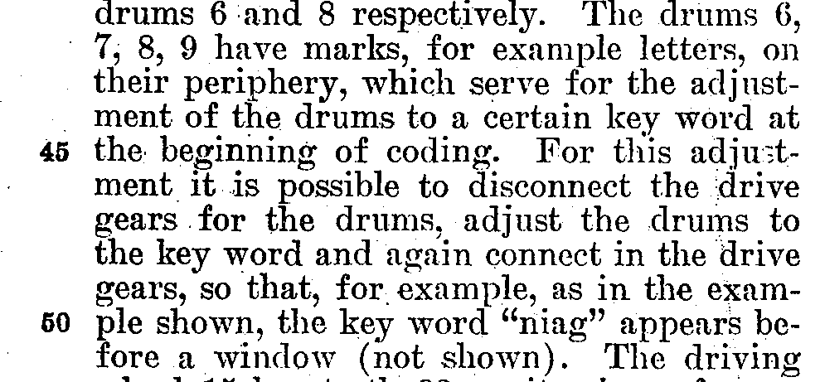

The key code/word determines the encryption key that is applied to a given letter of plaintext. The length of the encryption key is determined by the number of rotations for the key code/word to reappear in the windows of the stepping rotors. For example, supposing the same letter key on the keyboard was continually pressed, what would you observe? Starting with the initial key code/word, RHV in a three (3) stepping rotor machine, each time the same letter key is pressed the key code/word showing the windows would change. Eventually, though, as one kept pressing the same letter key, the initial key code/word would reappear in the windows of the three (3) stepping rotors. However, it would take 262 = 676 rotations of the fast stepping rotor, 26 rotations of the medium stepping rotor, and 1 rotation of the slow stepping rotor for the initial key code/word to reappear. In other words, the key is of length 263 = 17,576. However, as mentioned in Hodges’ book,

But there was much more to the machine actually in military use. For one thing, the three rotors were not fixed in place, but could be removed and replaced in any order. Until late 1938 there was a stock of just three rotors, which therefore allowed a total of six arrangements. In this way, the machine offered different alphabetic substitutions. [Hodges 1983, p. 168]



vvv

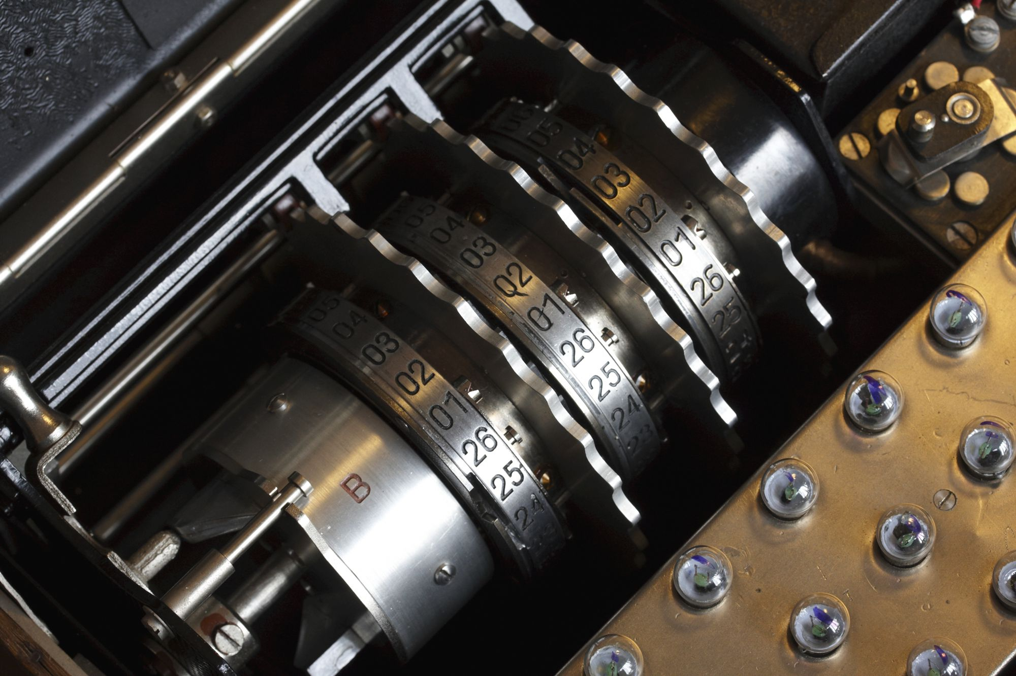

**FIGURE 1-2d – The Three (3) Stepping Rotors of an Enigma Machine. Note, the important questions with respect to this picture are as follows. First, which of the three (3) stepping rotors is the fast, medium, and slow one? Second, where is the reflecting rotor (a.k.a., the reflector)? The answers to these questions can be found, as explained in the text, at the following website:** [**http://www.pbs.org/wgbh/nova/military/how-enigma-works.html**](http://www.pbs.org/wgbh/nova/military/how-enigma-works.html) **. From left to right, the arrangement of the rotors is as follows: 1) the far left rotor embossed with the letter ‘B’ is the reflector [Umkehrwalze]; the next three (3) rotors with serrated edges are, respectively, the slow, medium and fast stepping rotors [Walzen]; and the black rotor at the far right is the fixed or entry rotor [Eintrittwalze]. (Source: Technical University of Denmark,** [**http://www.matematiksider.dk/enigma_dtu_eng.html**](http://www.matematiksider.dk/enigma_dtu_eng.html) **.)**

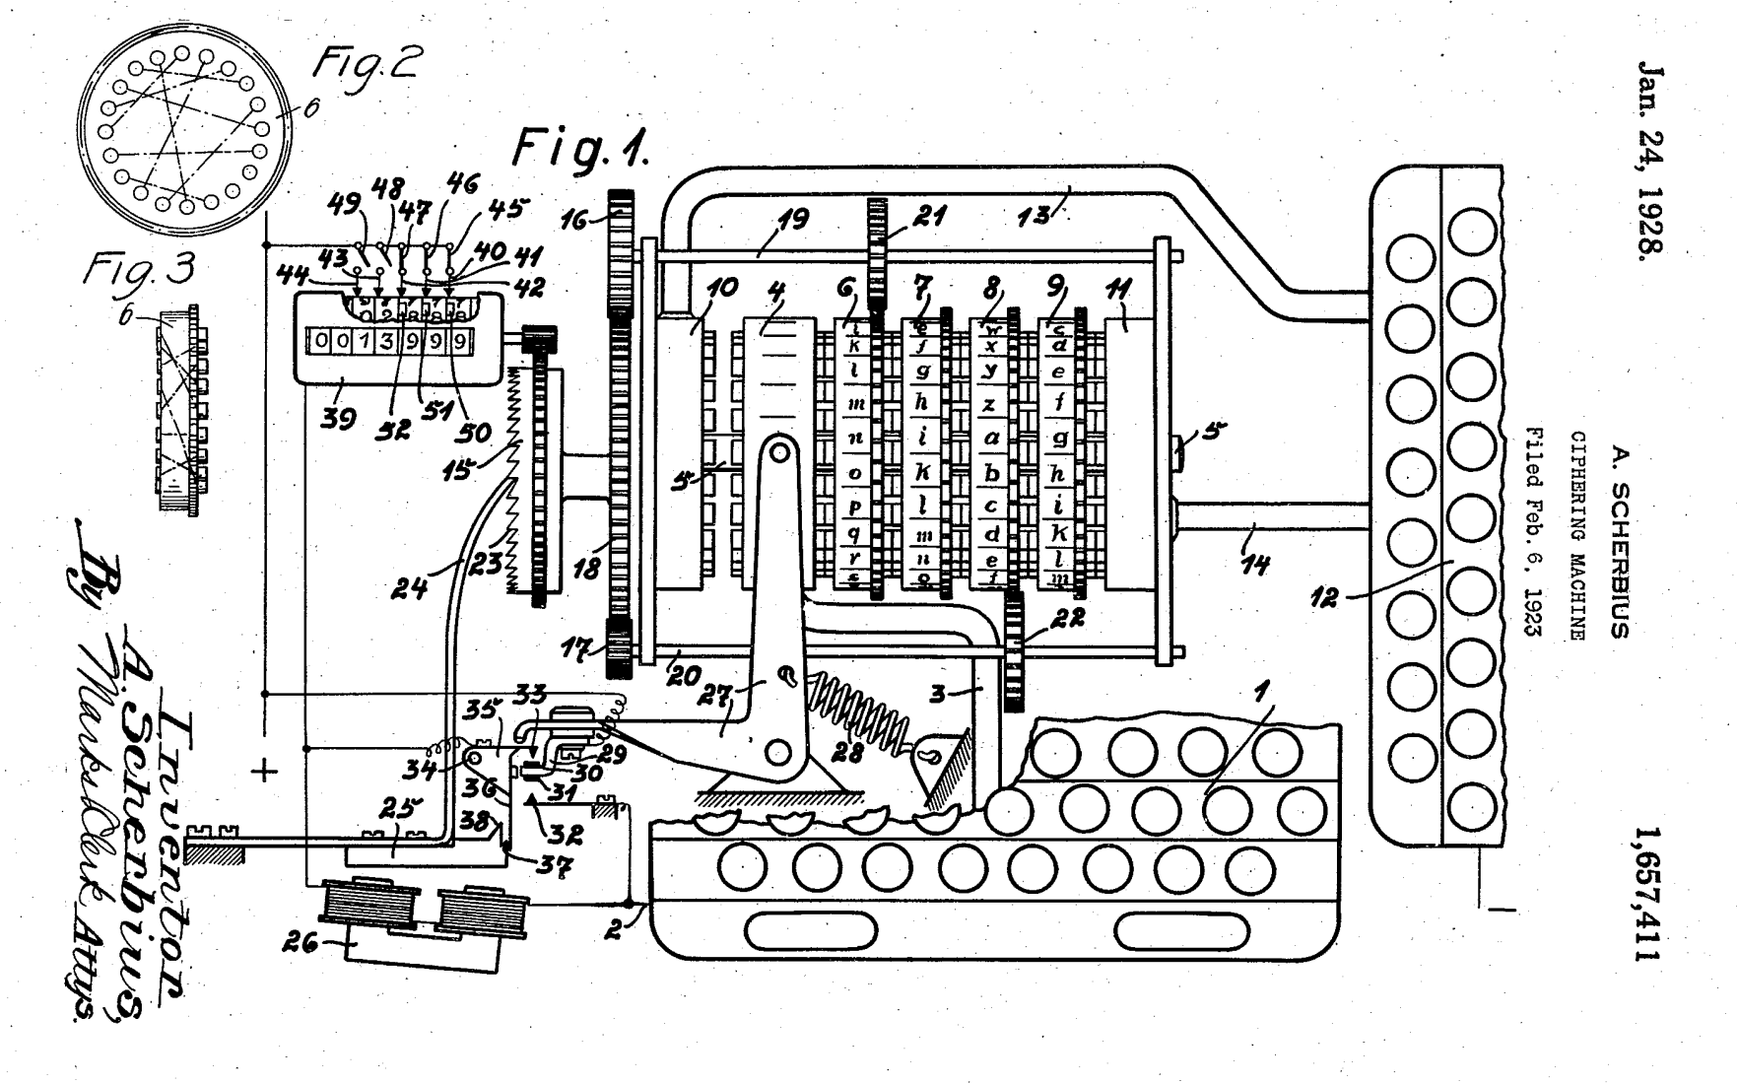

**FIGURE 1-2e - Diagram of a Commercial Enigma Machine taken from Sheet 1 of the US Patent 1,657,411. Note, for the sake of simplicity only drive gears (21 & 22) for rotors 6 & 8, respectively, are shown. (Source: Arthur Scherbius (Assignors/Inventors), Chiffriermaschinen Aktiengesellschaft [Cipher Machines, Joint-Stock Company], Berlin (Assignee); Ciphering Machine; US Patent 1,657,411; January 24, 1928; 7 pp.; URL:** [**http://www.uspto.gov/old-index.html**](http://www.uspto.gov/old-index.html) **.)**

The arrangement of the stepping rotors, the location of the reflector, and the stationary rotor can be found on various websites. For example, the PBS (Public Broadcasting System) Nova website, <http://www.pbs.org/wgbh/nova/military/how-enigma-works.html> , provides the following annotated schematic drawing of a three (3) stepping rotor military Enigma machine.

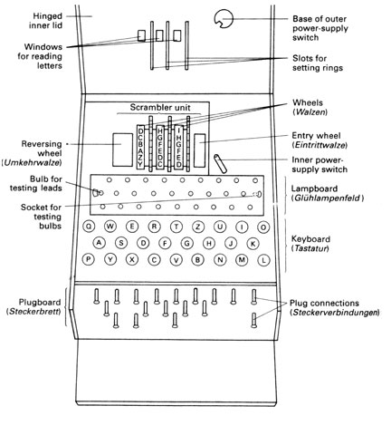

**FIGURE 1-3 – Annotated Schematic Drawing of a Military Enigma Machine (Source:** [**http://www.pbs.org/wgbh/nova/military/how-enigma-works.html**](http://www.pbs.org/wgbh/nova/military/how-enigma-works.html) **.).**

**TABLE 1-1 – Enigma Machine Versions According to Wrixon’s Book (Source: Fred B. Wrixon; Codes, Ciphers & Other Cryptic & Clandestine Communication; Barnes & Noble Books; 1998; pp. 260-263.)**

|  |  |  |  |
| --- | --- | --- | --- |
| Enigma Machine Version | Number of Stepping + Non-Stepping Rotors | Reflecting Rotor |  |
|  |  |  |  |
| A | 4 | No ¥ |  |
| B | - | - |  |
| C | 4 | Yes £ |  |
| D | 4 | Yes € |  |
|  |  |  |  |

¥ According to Wrixon, “Model A began with four rotors driven by four geared wheels [Wrixon 1998, p. 262].”

£

€

There is one last confounding feature of the Enigma machine, which was mentioned in Hodges’ biography of AlanTuring,

Obviously, the rotors had to be marked in some way on the outside so that the different positions could be identified. However, here entered yet another element of complexity. Each rotor was encircled by a ring bearing the 26 letters, so that with the ring fixed in position, each letter would label a rotor position.* (In fact, the letter would show through a window at the top of the machine.) However, the position of the ring, relative to the wirings, would be changed each day. The wirings might be thought of as labeled by numbers from 1 to 26, and the position of the ring by the letters A to Z appearing in the window. So a ring-setting would determine where the ring was sit on the rotor, with perhaps the letter G on position 1, H on position 2, and so forth.

* The rather tiresome complication introduced by the ring-setting is, unfortunately, required to make sense of what the Poles achieved. It will play no part thereafter. [Hodges 1983, pp. 168-169]

The following figure depicts the construction, in exploded view, of an Enigma rotor, and it shows the relationship between the ring and the notch used to advance the next slowest rotor, if there is one. An important fact revealed by this figure and its accompanying text is that the notch location with respect to the ring holding the characters that appears in the stepping rotor window is fixed and independent of the ring settings, i.e., the ring settings only change the mappings, nothing else.

The rotors (Walzen in German) are the most important elements of the machine. These round disks [9], approximately 4 inch in diameter, are made from metal or bakelite and have a core with 26 spring-loaded contacts [6] on the right side, scramble wired [5] to 26 flat contacts [4] on the left side, with a hollow axle in the center [8]. On the outside of the wiring core there's a movable ring [3] with 26 numbers or letters and a notch [1]. This ring is rotatable and is locked with a sprinloaded pin (Wehrmacht) [7] or two springloaded arcs (Kriegmarine) into any of the 26 positions. Changing the position of the ring will change the position of the notch and alphabet, relative to the internal wiring. This setting is called the ring setting or Ringstellung and its position is visible by a dot marking [2]. Each rotor has on its left a notch [1] and on its right a ratchet [10]. These are used by the stepping mechanism to advance the rotors. The internal wiring is different for each rotor. This wiring represents a substitution encryption. The combination of several rotors, in ever-changing positions relative to each other, is what makes the encryption so complex.

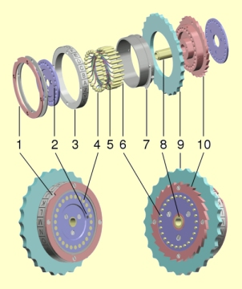

The machine was introduced with three rotors. In 1939 the set was extended to five rotors, marked with Roman numerals I, II, III, IV and V, all with a single notch. The Kriegmarine extended this set of rotors with another three rotors called VI, VII and VIII, each with two notches. In 1942, the Kriegsmarine M4 introduced a fourth rotor. To achieve this, the wide B and C reflectors from the three rotor version were replaced by thin B and C reflectors, leaving room for the special fourth rotor. The fourth rotors were of two configurations, named Beta and Gamma, with spring-loaded contacts on both sides, making them incompatible with the other eight rotors.

FIGURE 1-4 – Explanation of the Construction of an Enigma Rotor (Source: <http://users.telenet.be/d.rijmenants/en/enigmatech.htm> .).

# 2 - Functional Description of the Encryption and Decryption Process

Konheim’s book gives a very clear a succinct description of the …

Hhh

# 3 - Top-Level Description of the Software Used to Simulate an Enigma Machine

There is no complicated mathematics needed to code the Enigma simulator. A brute force approach would simply use a set of integer arrays for the various mappings with each array element being pointed to via cyclic indices. Cyclic indices are indices that simply wrap around. For example, suppose the Enigma simulator only had four (4) letters from the Roman alphabet (A, B, C & D). Such a machine could be simulated using integer arrays containing four (4) elements with the following indices 0, 1, 2 & 3. In order to simulate the circular stepping rotors with a linear array, the array indices will have to be cyclic in the sense that as you increment or decrement them, they never fall off the front or back end of the array. In order to make the indices cyclic, after each increment, decrement or both, modulo arithmetic must be applied to them to keep them in the valid range: 0, 1, 2 & 3. There are two (2) rules that will be required to make the coding of the cyclic indices function properly:

1. always calculate the modulo of the sum of the indices, never the sum of the individual modulo for each index; and
2. one must have a way of dealing with a negative modulo.

Rule #1: Anytime you perform addition of two integers to form a new integer to be used as an index to an array, a modulo division of the sum must be performed before using the sum as an index. In other words, suppose you have to add together two indices, and use the result as an index to the array of four letters. In C++, the correct way to perform the addition is as follows, [14]

intOutput = Array[(intIndex1 + intIndex2)%N];

In C++, the incorrect way to perform the addition would be as follows,

intOutput = Array[(intIndex1)%N + (intIndex2)%N];

The reason the second approach is incorrect is that the sum of modulo additions [the second approach] does not necessarily equal the modulo of the sum [the first approach]. For example, in the case where N = 4, the correct approach yields an index that is in the valid range (0, 1, 2 or 3)

(3-1)



while the incorrect approach yields an index value outside the valid range,

(3-2)



Rule #2: the other problem with using the C++ language is what happens when, for example, we perform a modulo division of a difference between indices. For example, consider the following C++ statement,

intDiff = (0 – 1)%N;

where, say, N =4 . The *lvalue* (left-value), intDiff, will equal -1, which will cause a runtime error if it is used as an index value since index values are only allowed to be non-negative and, further, must not fall off the front or rear end of the array.[15] The simplest solution to this problem is anytime a difference is formed between indices, the resulting *lvalue* must be passed through the following ‘if’ statement to convert it into a positive integer value in the range 0-3,

if(lvalue < 0)

{

lvalue = N + lvalue;

}

else

{

// Do nothing.

}

One other point needs to be made about the use of modulo arithmetic. If the Enigma software simulator uses pointers instead of array indices, a problem arises. While pointers to contiguous memory data structures, such as arrays of primitive types, objects or structures, can be incremented and decremented like integer variables, there is no built-in modulo operator for pointers, i.e., trying to use the ‘%’ operator with pointers will lead to a compile-time error. In other words, if you decide to use pointers, you will have to write your own modulo operator – perhaps by overloading the normal modulo operator ‘%’.

If we represent the circular, stepping rotors as cyclic, linear arrays, then we are faced with another problem: lack of bidirectionality in the mappings. The following drawing depicts a pair of cyclic, linear arrays as the data structure representing a stepping rotor. The rotor itself is shown in the middle of the drawing with two-headed arrows, which represent the mappings/wirings of the rotor contacts, going from left to right or right to left, depending on the direction of the signal through the rotor. Clearly, the mappings for the real rotor are bidirectional. However, if we attempt to represent these same mappings with a single, cyclic, linear arrays, we end up with a problem: a unidirectional mapping. For example, the “Forward Array” found at the top of the drawing works well enough in representing the mappings of the stepping rotor when going from left to right, but not in the opposite direction. Likewise, the “Reverse Array” found at the bottom of the drawing works well enough in representing the mappings of the stepping rotor when going from right to left, but not in the opposite direction. The words ‘Yes’ and ‘No’ in the Reverse Array indicate whether or not the mappings match those found in the Forward Array.

What this example is meant to show is that, in general, it takes two (2) different, cyclic, linear arrays to represent the mappings of a stepping rotor.

Note, so far we have only discussed stepping rotors, but the same thing is true for the single fixed rotor that is to the right of the fast rotor position; the reflector is also technically a fixed rotor in that it does not rotate, but it has a special type of mapping/wiring that we shall discuss later in this section. In addition, the reflector only has contacts on only one face, instead both faces as is the case with the stepping and fixed rotors, and it is for this reason that the reflector is sometimes known as a half-rotor.

0

1

2

3

0

1

2

3

Reverse Array:

[0] = 0 ; Yes

[1] = 3 ; No

[2] = 1 ; No

[3] = 2 ; No

Forward Array:

[0] = 0

[1] = 2

[2] = 3

[3] = 1

Rotor

**FIGURE 3-1 – A Four (4) Alphabet [A = 0, B = 1, C = 2, & D =3] Stepping Rotor Represented by a Cyclic, Linear Array. The Reverse Array does not match the Forward Array. (Source: Tom Cuff.)**

While the stepping and fixed rotors each require two (2) different, cyclic, linear arrays to represent their mappings/wirings, the same thing is not true of the reflector (half-rotor) and the plug board, which can be regarded as a type of fixed rotor. First we will consider the plug board.

There are only two (2) types of mappings allowed with the plug board: 1) identity mappings, which always come in pairs, and 2) pair-wise swaps. Since we are considering a 4 letter Enigma machine, we can define the allowed mappings as follows:

[ i ] = i

[ j ] = j

[ k ] = l

[ l ] = k

where the indices, i, j, k & l are not necessarily in numerical order, and the first two mappings is a pair-wise identity mapping and the second two mappings is a pair-wise swap. The pair-wise identity mapping represents a patch cord or jumper cable not being plugged into the plug board, while the pair-wise identity mapping represents a patch cord or jumper cable being plugged into the plug board. Although it may be obvious, it bears saying that once an index has been used in a mapping, it cannot be used again in a different mapping on the same plug board.

The interesting feature of the identity and pair-wise swap mappings is that only a single, cyclic array is needed to represent any mixture of these two types of mappings because the array will be bidirectional by default for these mappings, see Fig. 3-2.

0

1

2

3

0

1

2

3

Reverse Array:

[0] = 2 ; Yes

[1] = 1 ; Yes

[2] = 0 ; Yes

[3] = 3 ; Yes

Forward Array:

[0] = 2

[1] = 1

[2] = 0

[3] = 3

Plug Board

**FIGURE 3-2 – A Four (4) Alphabet [A = 0, B = 1, C = 2, & D =3] Plug Board Represented by a Cyclic, Linear Array. The Reverse Array does match the Forward Array. (Source: Tom Cuff.)**

There is only a single type of mapping allowed with the reflector (half-rotor): pair-wise swaps. Since we are considering a 4 letter Enigma machine, we can define the allowed mappings as follows:

[ i ] = j

[ j ] = i

[ k ] = l

[ l ] = k

where the indices, i, j, k & l are not necessarily in numerical order, and all the mapping are pair-wise swaps. Although it may be obvious, it bears saying that once an index has been used in a mapping, it cannot be used again in a different mapping on the same plug board.

The interesting feature of the identity and pair-wise swap mappings is that only a single, cyclic array is needed to represent any mixture of these two types of mappings because the array will be bidirectional by default for these mappings, see Fig. 3-3. Note, the reflector depicted in Fig. 3-3 is shown as a full-rotor as opposed to a half-rotor because, in the software simulator, signals entering the left hand side of the reflector will exit from the right hand side and go to the reverse arrays for the Fast, then Medium, and, finally, Slow stepping rotors.

0

1

2

3

0

1

2

3

Reverse Array:

[0] = 2 ; Yes

[1] = 3 ; Yes

[2] = 0 ; Yes

[3] = 1 ; Yes

Forward Array:

[0] = 2

[1] = 3

[2] = 0

[3] = 1

Reflector

**FIGURE 3-3 – A Four (4) Alphabet [A = 0, B = 1, C = 2, & D =3] Reflector (Half-Rotor) Represented by a Cyclic, Linear Array. The Reverse Array does match the Forward Array. (Source: Tom Cuff.)**

One of the students in the class indicated that he thought that if one failed to use a reverse array mapping on a stepping rotor that the resulting Enigma machine would not work in the sense that it would not self-invert. Fig. 3-4 shows what happens in a standard Enigma machine when a bidirectional mapping is used. The machine obviously self-inverts since if one reverses the arrows associated with 0 and 3, the 0, which was the input becomes the output, and the 3, which was the output becomes the input.

In Fig. 3-5, while the forward mapping (in black) is correct, the reverse mapping is not, i.e., the reverse mapping (in yellow) is what one would get if one used the forward array instead of the reverse array. But notice that the machine still self-inverts if the input and output are interchanged.

0

1

2

3

0

1

2

3

Reverse Array:

[0] = 3 ; No

[1] = 0 ; No

[2] = 1 ; No

[3] = 2 ; No

Forward Array:

[0] = 1

[1] = 2

[2] = 3

[3] = 0

Rotor

Reflector

0

3

**FIGURE 3-4 – A Four (4) Alphabet [A = 0, B = 1, C = 2, & D =3] Enigma Machine with a Single Stepping Rotor and a Reflector. Note, the Reverse Array does not match the Forward Array, and the Reverse Array is used when going back through the stepping rotor in this case. (Source: Tom Cuff.)**

0

1

2

3

0

1

2

3

Reverse Array:

[0] = 3 ; No

[1] = 0 ; No

[2] = 1 ; No

[3] = 2 ; No

Forward Array:

[0] = 1

[1] = 2

[2] = 3

[3] = 0

Rotor

Reflector

1

0

0

**FIGURE 3-5 – A Four (4) Alphabet [A = 0, B = 1, C = 2, & D =3] Enigma Machine with a Single Stepping Rotor and a Reflector. The Reverse Array does not match the Forward Array, and the Reverse Array is not used when going back through the stepping rotor in this case. (Source: Tom Cuff.)**

# 4 - How to Test the Software Used to Simulate an Enigma Machine

After the software that purports to simulate the Enigma machine has been written, the question naturally arises as to how “prove” that the software is indeed functioning properly. There are basically six (6) tests that must be performed and successfully executed to assure proper operation of the Enigma software:

1. Compiles and Runs Test – This is really the first test that the Enigma simulator must pass. If the code will not compile, or if it does compile, but it will not run without crashing or producing a runtime error, then it is not functioning properly. This may seem to be so obvious a criterion as to require no mention, but it is nevertheless a very real requirement for *any* code.
2. Single Letter Entry Test - Choose a single letter, say ‘A’, and repeatedly enter the letter through the keyboard, while, at the same time, observing the key code [of the three stepping rotors] and the display output. If the software is functioning properly, the letter ‘A’ should never map to itself since it is the job of the reflector to assure that this does not happen. The number of times the letter ‘A’ must be entered to complete this test can be determined by looking at the key code. If the initial key code is say the default, AAA, then each time the ‘A’ key is pressed the key code will change – increment. When the initial key code is reappears, that is when the testing can stop. If the letter ‘A’ has not mapped to itself by then, then the test is a partial success in that it implies that the reflector is functioning properly. However, in order for this test to be a complete success, during one complete cycle of the key code from the initial value of the key code to its reappearance, the letter ‘A’ must map to each other letter of the alphabet at least once. The proof of this last statement will be provided later in this section of this document.
3. Repeated Entry Test - In this test, each time a key on the keyboard is pressed, the key code must be carefully observed to make sure that it increments in an orderly manner. For example, one very common problem with the software used to simulate the Enigma machine is that it causes a race condition in the slow stepping rotor, i.e., the slow stepping rotor advances (rotates) faster than the medium stepping rotor.[16] If racing is detected, then the software is not functioning properly. Note, the odometer arrangement of the stepping rotors, wherein one rotor drives its left hand counterpart, is analogous to a digital electronics shift register, binary counter, etc. and such serial arrangements of flip-flop gates can, if improperly designed and applied, exhibit race conditions.
4. Offset Test – In this test, the initial key code must be something different than the default key code, AAA. Changing the initial key code must cause a different number of key strokes to be entered before the stepping rotors change when compared to the default key code setting. A similar thing occurs if one fixes the initial key code, but changes the location of the notch location on one or more of the stepping rotors (only on the Fast or Medium rotors since the Slow rotor notch does not drive any other stepping rotor.).
5. Encryption Test - The penultimate test is simply verification that the mappings are what are expected for the combination of a) stepping rotors, b) location (Slow, Medium and Fast) of the stepping rotors, c) ring settings of the stepping rotors, d) reflector configuration, and e) plug board configuration. Of course, the issue here is how does one construct all the possible mapping sequences? If one had a “known good’ Enigma simulator, then that could be used to construct all possible mapping sequences. But that is just the point of the matter, we normally don’t have such a device.
6. Decryption Test - The final test consists of submitting encrypted text to the software to be converted into plaintext (clear text). One might think that this is a redundant test given that the software has passed the Encryption test, but the caveat in this final test is that the encrypted text must come from an Enigma simulator designed and coded by another group, but having the same configuration of stepping rotors, ring settings, and plug board wiring. This test can be thought of as a reproducibility test, i.e., two Enigma software simulators designed and coded by two different groups are the “same” if they can code and decode each other’s messages. Of course, this “sameness” does not imply that the two simulators were coded properly, just that they function the same, i.e., they could have both been designed and coded the *same* wrong way. If the two Enigma simulators disagree, then the question arises as to which one is correct, admitting, of course, the possibility that both could be incorrect, just in different ways.

The first four (4) tests (#0 – Compiles and Runs, #1 - Single Letter Entry Test, #2 - Repeated Entry Test & #3 – Offset Test) provide necessary but not sufficient conditions for the proper functioning of the Enigma simulator. In other words, the Enigma simulator must pass these four tests to be functioning properly, but passing these four tests does not guarantee proper functioning. Some further explanation will be needed in order to understand the previous statement. Consider the following truth-functional relation, [17]

(4-1a)



(4-1b)



which can be recast as the following English language sentence,

If the Enigma simulator is functioning properly, then it passes tests #0, #1, #2 & #3.

In Eq. 1, the antecedent (*p*), “Enigma simulator functioning properly” implies “→” the consequence (*q*) “Passes Tests #0, #1, #2 & #3.” In other words, assuming that Eq. 1 is TRUE, the consequence “Passes Tests #0, #1, #2 & #3.” being TRUE is a necessary condition for the antecedent “Enigma simulator functioning properly” to also be TRUE. However, Eq. 1 can be TRUE and the consequence can be TRUE without the antecedent being TRUE, i.e., the antecedent could be FALSE. The following is the truth table for the truth-functional implication in Eq. 1,

**TABLE 4-1 – Truth Table for the Truth-Functional Relation (Source: Irving M. Copi, Carl Cohen, Kenneth McMahon; Introduction to Logic, 14th Ed.; Prentice Hall; 2011; p. 303. )**



|  |  |  |
| --- | --- | --- |
| *p* | *q* | *p → q* |
|  |  |  |
| T | T | T |
| T | F | F |
| F | T | T |
| F | F | T |
|  |  |  |

Unfortunately, Eq.1 does not imply that the converse of Eq. 1 ,

(4-2)



is TRUE. It might seem impossible for an Enigma simulator that has passed Tests #0, #1, #2 & #3 to have some hidden flaw, but it is, nevertheless, true. An example or two will make this plain. Suppose there is a logical or typo error in the Enigma simulator that causes the signal from the fast stepping rotor to detour around the medium stepping rotor and go directly to the slow stepping rotor, and to do the same thing in the reverse direction. Such an Enigma simulator would still appear to work in that it passes Tests #0, #1, #2 & #3, but it would, in fact, be flawed. An even more difficult logical error to catch would occur if, for example, the notch position on one or more of the rotors was incorrect, e.g., suppose the medium stepping rotor was supposed to advance the slow stepping rotor during its transition between the letters ‘C’ and ‘D’ instead of between letters ‘Z’ and ‘A’. Such an Enigma simulator would certainly pass Tests #0, #1, #2 & #3, but it would obviously not be functioning as desired.

What about Test #4 & #5? These two tests provide both necessary and sufficient conditions to show that the Enigma simulator is working. In other words, …

(4-3)



One might ask why perform Tests #0, #1, #2 & #3, which only provide necessary but no sufficient conditions, to show that the Enigma simulator is working? The answer is that if the simulator fails Tests #4 and/or #5, we only know that there was a failure or failures but not why. On the other hand, Tests #0, #1, #2 & #3 are diagnostic tests in the sense that they test specific portions of the simulator code. Test #1, for example, can reveal problems with the reflector since that is the portion of the code responsible for preventing input letters from mapping back to themselves.

With respect to Test #4, the question naturally arises as to how to find plaintext and cipher text from a known good Enigma machine – not an Enigma simulator. Since we are supposed to simulate the German Railway (Rocket) Enigma, it would essential to find plaintext and cipher text from this machine. Unfortunately, it is difficult to locate *any* sites on the Internet that have plaintext and cipher text from a wide variety of Enigma machines, including the one in which we are interested. Perhaps the only thing we can do is convert our simulator to one of the models for which plaintext and cipher text is available. It should be noted that the plaintext is usually not directly “readable” by itself due to two (2) factors, which essentially double and triple encrypt the actual message: 1) the actual message was in German; and 2) when the actual message was formatted for transmission, but before it was formatted for the Enigma machine, it was converted to a standard form via a codebook; and 3) when the formatted message was ready, it was then converted into fixed size groups of letters for encrypting by the Enigma machine. All of this needs some clarification before we continue.

The actual message represents the information that the sender wants to communicate. Of course, this actual message would have been composed in the German language or the language of one of its allies, which is essentially the first level of encryption. This information might be railway timetables, meteorological data, convoy sightings, etc. Because of telecommunication channel limitations, the actual message must be condensed into as compact and easy-to-read form as possible. For this purpose, there were codebooks that gave directions for how to format the actual message so that it would not be verbose or require interpretation by the receiver. This conversion to a standard form is the second level of encryption since if you do not possess the codebook interpreting the plaintext may be difficult if not impossible. The codebooks were also essential to the code breakers because they provided the cribs, standard words or abbreviations that certain types of messages had to have, that made cracking the code less arduous that it might otherwise have been. Because of this, the Allies went to great lengths to recover codebooks from German submarines, surface ships, Army units, etc. An example of a real Enigma message will hopefully make all this more understandable.

…

One would think that the Internet would be full of test strategies for Enigma simulators, but, so far, I have not had much success locating such procedures. I was able, though, to locate a Master’s Thesis in which the author ran into the reproducibility problem amongst different software Enigma simulators,

It was only after a few weeks into designing an Enigma simulator that I discovered several simulators already existed, two I shall refer to belong to Andy Carlson(Fig.1) and Russell Schwarzger(Fig.2). Testing both Enigmas, I was quickly aware that the two simulators gave different answers despite looking similar in design. It was at this point that I felt that my design plan needed to be re-evaluated and altered to prevent myself ‘reinventing the wheel’. After some time spent investigating the two Enigma simulators and trying to figure out why they gave different outputs I became aware of the lack of information conveyed by the two machines. The two machines looked the same because they looked like an Enigma, but their respective inner workings must have been different for the results to be so (with all other things being equal, i.e. the Enigma settings). This was the only deduction I could make from each of the two machines. However, if I could visually demonstrate the paths the electrical signal took passing through the machine I could at least justify any answer my simulator gave rather than simply churning out possibly meaningless (and even random) characters. This would serve the purpose of improving understanding of the machine and increase the scope beyond the two existing machines. [Wong 2003, p. 5][18]

His solution to this conundrum was as follows,

Going back to the question I asked about which of the two previous Enigmas were accurate, it occurred that this question would be asked of mine. The definitive answer of course would be to compare messages encrypted by those simulators with an actual Enigma machine. For lack of available real life Enigmas, this is just not feasible.

But, given that the action motion of an Enigma was relatively simple and consistently reported, the most likely source of inaccuracy was in the mappings of each wheel, for authenticity I wanted an accurate source for which to base my wheel mappings on, but in theoretically, so long as there existed a mapping for each of my wheel it should not affect the enciphering ability of my simulator.

1. To prove that any machine is consistent with itself a message must be able to encrypt and decrypt itself using the same base settings. This would be the most fundamental requirement of any Enigma machine and will be the first test I shall perform.

2. As previously mentioned, the only reason why two simulators should produce different results would most probably lie in the order of the mappings for each wheel. If I used the same mappings as any other Enigma, my results should be identical. For this reason I have chosen to use the same wheel mappings as Andy Carlson’s Enigma so I could compare my results with an existing machine. [Wong 2003, pp. 6-7]

I disagree with Wong’s testing approach in that it does not check for fundamental errors in the code such as a letter mapping to itself or race conditions in the stepping rotors. More to the point, Wong claims that a failure of the reproducibility test, entry #2, above, “… would most probably lie in the order of the mappings for each wheel.” This rather uncertain (“probably”) and narrow view of the cause of a failure in the reproducibility test, further erodes any confidence, at least on my part, in using Wong’s testing approach.

# 5 - Breaking the Enigma Machine Cipher – If it can be done

One of the great myths about the efforts of the British coder breakers at Bletchley Park during WWII is that they brute force “broke” the Enigma codes. Nothing could be further from the truth. A purely brute force attack on Enigma code would entail using only the cipher text – no cribs would be allowed. [19] A crib is word, phase, key code, etc. or such that one knows *a priori* is going to be in the encrypted message. The following excerpt from p. 405 of the 1995 *Cryptologia* paper by Gillogly briefly mentions the types of cribs the code breakers used.



An earlier paper in *Cryptologia* by Deavours and Kruh also makes this same point,[20]

… The first method was based on stepping through all rotor positions and computing, at each position, certain statistics which would indicate the correct cylinder positions had been attained. This method was a *ciphertext only* cryptographic attack and will not be discussed here. This first method was apparently, never put into use, probably because of German foresight in keeping the individual message lengths to about 200 characters (the maximum allowed length varied from time to time).

The second method, and the one used by the British, was based on cribs (probable plaintext). In this second method, a crib of suitable length was assumed to be in a certain position of a message and a device, the bombe, stepped through rotor position trying to determine at each position whether the assume plain/cipher correspondence was possible. [Deavours & Kruh 1990, p. 331]

As Andrew Hodges mentions in his biography of Alan Turing, in his discussion of the groundbreaking work done by the Polish Intelligence Service in the 1930’s,

They [the Poles] were only able to make these observations on account of the very particular way in which the machine was used. And they were only able to progress towards a regular decipherment of Enigma material by exploiting that method of use. **They had not broken the machine; they had beaten the *system*. [Emphasis added.]** [Hodges 1983, pp. 170-171]

By the word ‘system’, Hodges means the “system by which the Enigma machines were used.” The system by which the Enigma machines were used introduced cribs everywhere.

We shall examine the use of cribs later on in this section., but it should also be mentioned, at this point, that the use of the reflector in the Enigma machine, which gives the machine its convenient self-inverting property, is also a crib of sorts,

There was a practical advantage to this Enigma property. It meant that the deciphering operation was identical with the enciphering operation. (In group-theory terms, the cipher was self-inverse). The receiver of the message had only to set up the machine in exactly the same way as the as the sender, and feed in the cipher-text to recover the plain-text. There was no need to incorporate ‘encipher’ and decipher’ modes into the Enigma machine, which made its operation that much less liable to mistakes and confusion. But it associated with a grave weakness, in that the substitutions thus performed were always of this special kind, with the particular feature that no letter could ever be enciphered into itself. [Hodges 1983, p. 168]

To understand what Hodges means when he says that the self-inverting property of the Enigma machine is a “… grave weakness …”, consider the following scenario. Suppose you know that a particular enciphered message contains the word ‘KYLE’, and further suppose the total length of the message is 200 characters. Do we have to check the entire message? The answer is no. We only have to look at the four letter groups that do not have ‘K’ in the first position, or ‘Y’ in the second position, or ‘L’ in the third position, or ‘E’ in the fourth position. We can eliminate a large amount of the enciphered message by using the fact that the Enigma machine never enciphers a letter to itself. But we are getting ahead of ourselves, here. Let us return to the history of the efforts to break the Enigma code.

There are, in fact, so many contradictory stories about the Enigma machines and how their code was broken, that it is hard to know where to start. For example, the first electro-mechanical device used to help break the Enigma code was the Polish *Bombe*. According to Andrew Hodges,

By November 1938 they [the Poles] had actually built such machines – six in fact, one for each possible rotor order. They produced a loud ticking sound, and were accordingly called the *Bombes* [bombs]. [Hodges 1983, p.175]

Hodges’ explanation for the origin of the name *Bombes* is quite reasonable, except that it is contradicted by other sources,[21]



**FIGURE 5-1 – Description of the Origin of the *Bomba* or *Bombe* (Source: Chris Christensen; The Evolution of the Cryptographic Bombe; Department of Mathematics, Northern Kentucky University; 2/25/2010; p. 42).**

For those of us who are unfamiliar with the *Bomba* or *Bombe* as a desert, the following picture will be of some help.



**FIGURE 5-2 - A *Bombe* Desert (Source: Shona Crawford, Jasper Partington; The Ice Cream Book; Octopus Books Limited; 1980; p. 73.).**

According to a 2002 article by Kasparek, [22]

… the Polish cryptological “bomb” (*bomba*) took the French name “*bombe*” (by which the Poles doubtless introduced it to the British); … [Kasparek 2002, p. 97]



**FIGURE 5-3 - Description of the Origin of the Bomba or Bombe (Source: Chris Christensen; The Evolution of the Cryptographic Bombe; Department of Mathematics, Northern Kentucky University; 2/25/2010; p. 35).**

Xxx

# 6 – Implementing an Enigma Machine on an Arduino Platform

Although it is not part of the assignment for CIS208, it would be interesting to try and ‘port’ the Enigma simulator to an Arduino platform. For reasons that will be become readily apparent, ‘porting’ a full 26 letter alphabet Enigma simulator to an Arduino platform, although doable, would be tedious and expensive. For this reason, we shall only consider a 4 letter Enigma simulator.

The Arduino platform and its ancillary components can be purchased at Radio Shack. To keep the cost and construction difficulties to a minimum, we shall use an Arduino, model Uno Board ($34.99) plus an Arduino, model Proto Shield, Prototyping Board ($9.97).

XTAL, Clock Crystal for U4

7-12 VDC, 2.1 mm power connector

USB, Type B, female connector

XT, Clock Crystal for U3

U3, USB Serial Digital I/O Port Controller, ATMEL ATMEGA16U2-MU(R)

U4, Digital & Analog I/O Parallel Port Controller, ATMEL ATMEGA328P-PU

14 Digital Parallel I/O Ports

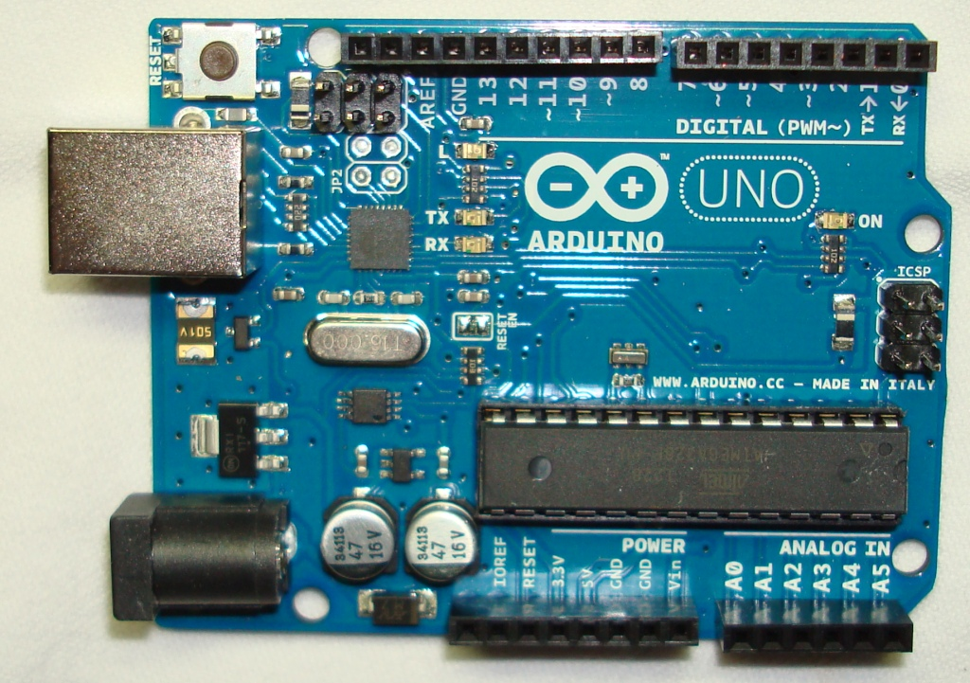

**FIGURE 6-1 – Component Side of the Arduino, model Uno Board, Rev. R3, Single Board Microprocessor. This board contains two (2) ATMEL controllers (microprocessors) with each microcontroller having its own clock crystal. Note, that the components are a mixture of through-hole and SMT (Surface Mount Technology) components. For example, U3 and XTAL are SMT components, while U4 and XT are through-hole components. Although the external packages of U3 (32-pad QFN (Quad Flat No Lead)) and U4 (28-lead Plastic DIP (Dual Inline Package)) are very different in size, their respective silicon dies (chips) on the inside of the packages are the same size. The reason why U4 is in a DIP, plugged into a socket, is for easy replacement in case one or more of the digital or analog I/O pins is shorted and damages the corresponding drive circuitry on U4. (Source: photograph by Tom Cuff.)**

Model and Rev. No.

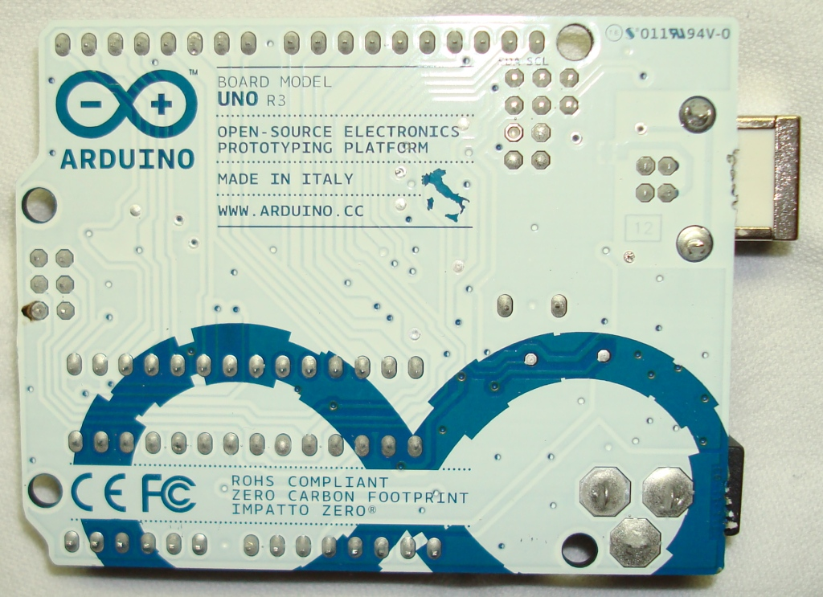

**FIGURE 6-2 – Through-Hole, Solder Side of the Arduino, model Uno Board, Rev. R3, Single Board Microprocessor (Source: photograph by Tom Cuff.).**



**FIGURE 6-3 – Schematic of the Arduino, model Uno Board, Rev. R3, Single Board Microprocessor (Source: for the schematic for the Arduino, model Uno Board, Rev. R3 see** <http://arduino.cc/en/uploads/Main/Arduino_Uno_Rev3-schematic.pdf>**, for the schematic for the Arduino, model Uno Board see** <http://arduino.cc/en/uploads/Main/arduino-uno-schematic.pdf> **).**

In order to easily connect to the analog and digital I/O pins and the various power pins on the Arduino, model Uno Board, Rev. R3, Single Board Microprocessor, the user needs to purchase an Arduino, model Proto Shield, see below. The Arduino, model Proto Shield sits on top of the Arduino, model Uno Board, Rev. R3.

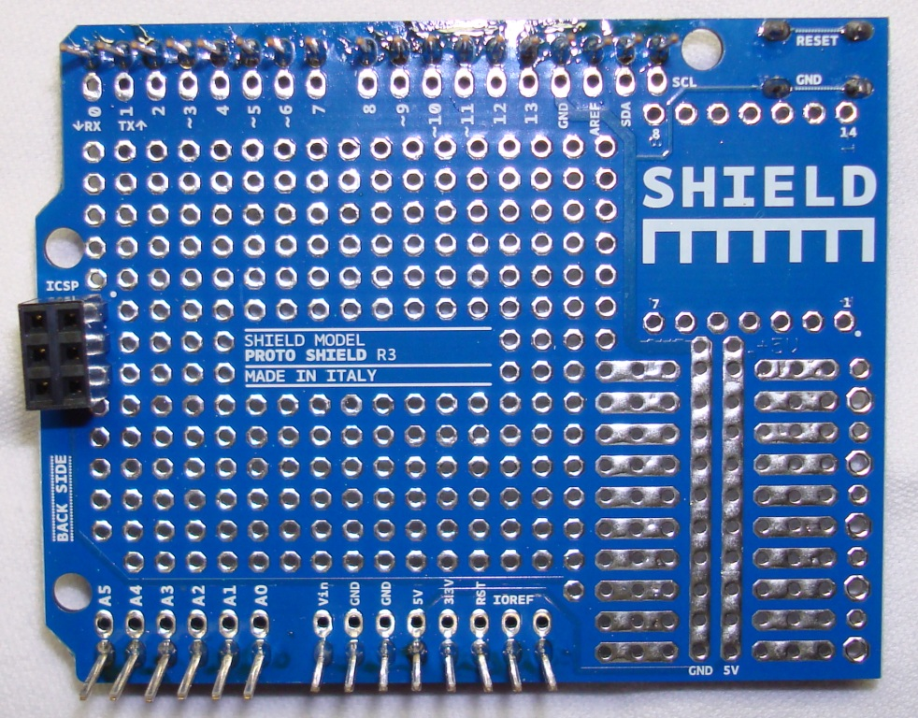

**FIGURE 6-4 – The bottom (through-hole solder) side of the Arduino, model Proto Shield, Prototyping Board (Source: photograph by Tom Cuff.).**

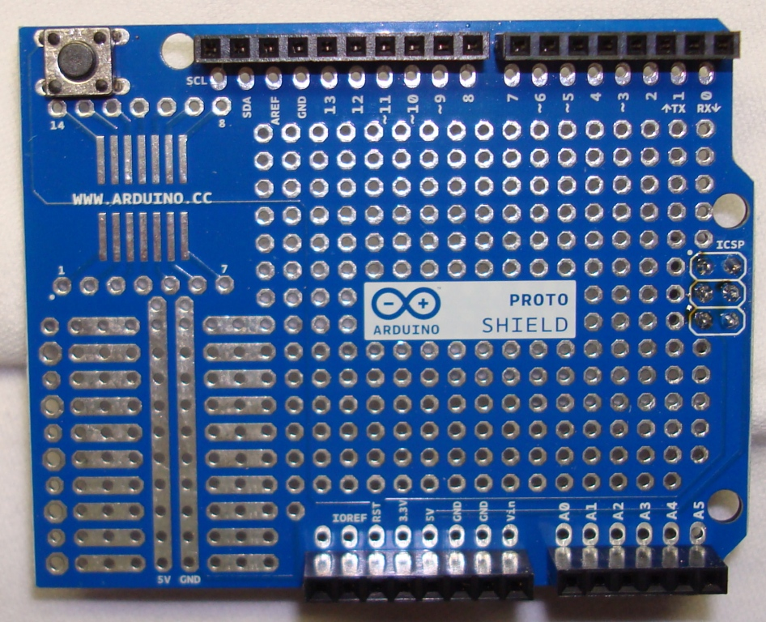

**FIGURE 6-5 – The top (component) side of the Arduino, model Proto Shield, Prototyping Board (Source: photograph by Tom Cuff.).**

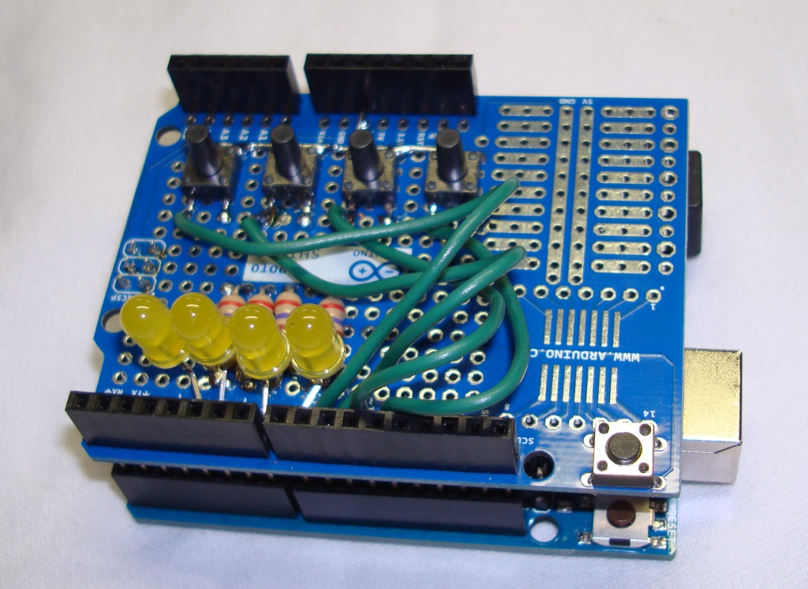

**FIGURE 6-6 – Oblique view of a populated Arduino, model Proto Shield, Prototyping Board mounted on top of a Arduino, model Uno Board, Rev. R3, Single Board Microprocessor. The four (4) LEDs (Light Emitting Diodes) have their anodes connected to digital I/O pins 5, 6, 7, & 8, which are configured as outputs. The cathodes of the LEDs are each attached to a 270 Ω, ½ W, carbon film resistor, which, in turn, is connected to GND (Ground, actually the Common). The four (4) SMT (Surface Mount Technology) momentary contact, pushbutton switches have one side connected to GND, and the other side to digital I/O pins 9, 10, 11, & 12, which are configured as inputs, each with an internal 20 kΩ pull-up resistor tied to +5 VDC. (Source: photograph by Tom Cuff.)**

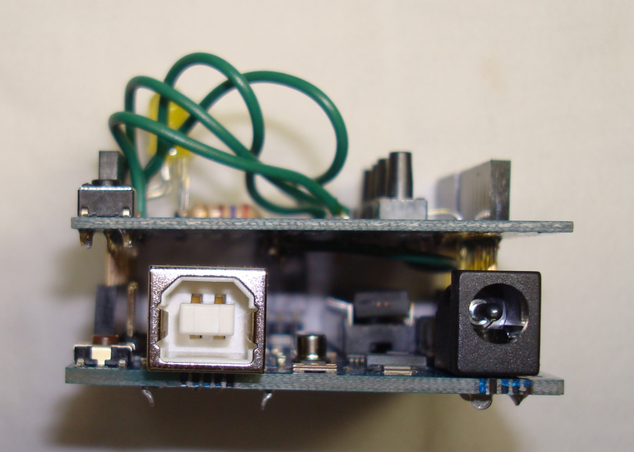

**FIGURE 6-7 – Side view of a populated Arduino, model Proto Shield, Prototyping Board mounted on top of a Arduino, model Uno Board, Rev. R3, Single Board Microprocessor (Source: photograph by Tom Cuff.).**

To communicate with the Arduino, model Uno Board, Rev. R3, Single Board Microprocessor, plug a USB cable with a Type A male connector into a USB port on your computer, and plug the other end of th cable with Type B male connector into the USB port of the Arduino, model Uno Board. Confirm that the computer ‘sees’ the Arduino, model Uno Board by going to the Device Manager and expanding the Ports (COM & LPT) icon, see below,

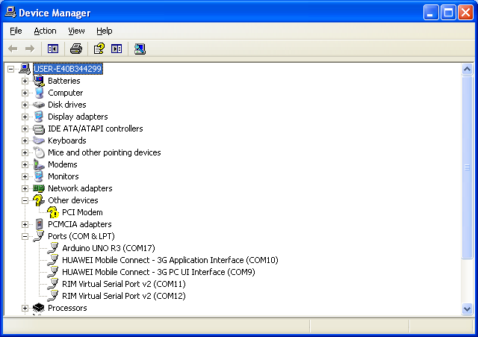

Launch the Arduino driver after extracting it from the Arduino 1.0.3 Windows zip file,

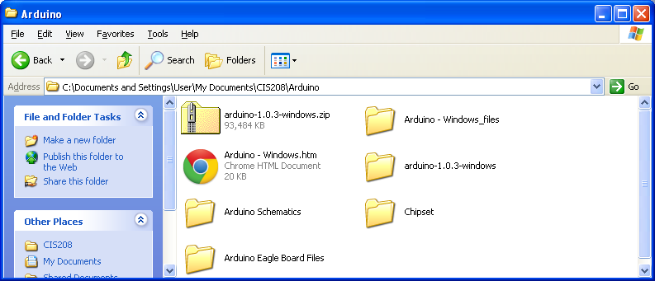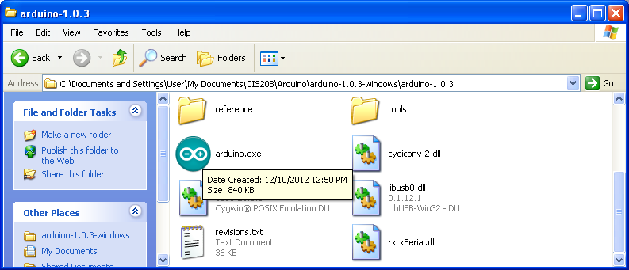

Double left-click on the Arduino.exe file to launch the driver, and, using the Tools entry in the main menu, make sure that the correct board has been selected and that the correct COM port has been selected,

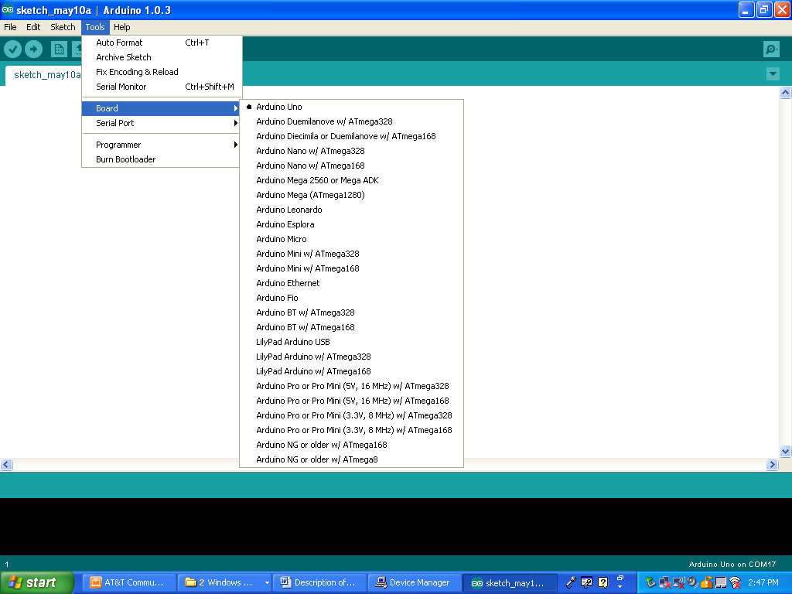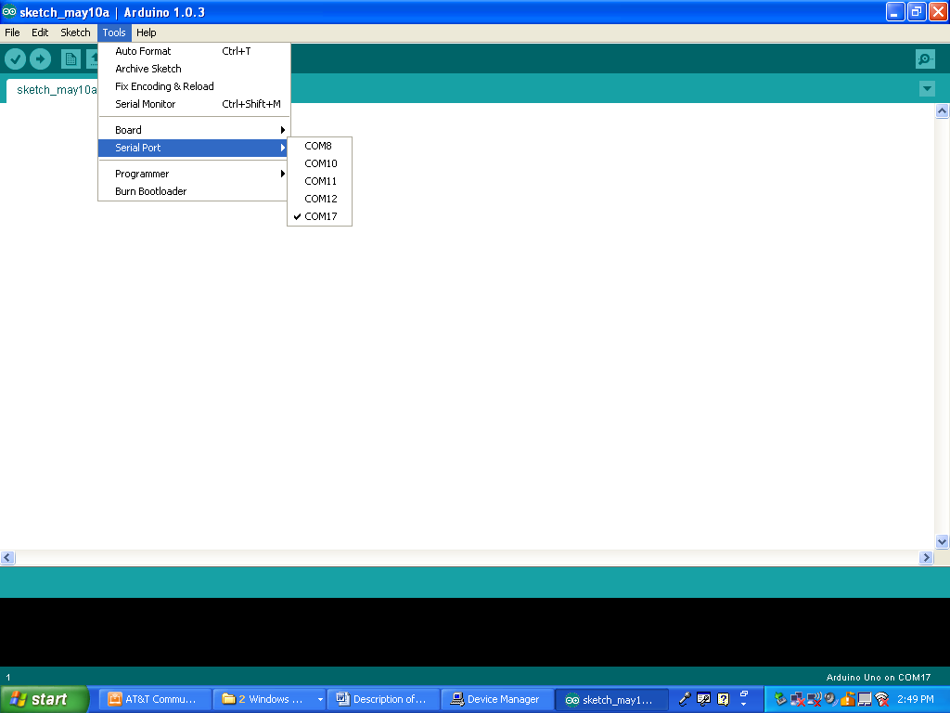

# Appendix A – Inter-Library Loan (ILL) at FCC

Some of the articles mentioned in this document had to be ordered through the Inter-Library Loan Department of the FCC Library. This can be done online as follows.

STEP #1 – Go to the FCC website at the following URL: <http://www.frederick.edu/> ,



STEP #2 - Left-click on the Library link at the top right, underneath the “Search FCC” field.



STEP #3 – Under the “Library” heading, left-click on the “Request Forms for Library Services” link.



STEP #4 – Under the “Request Forms” heading, go to the “Interlibrary Loan” sub-heading, and left-click on the “Magazine/Journal Articles” link. Fill out the form, and then scroll to the bottom and left-click the Submit Form button.



1. Andrew Hodges; Alan Turing: The Enigma; Simon and Schuster, Inc.; 1983; pp. 160-241, Chapter 4 – Relay Race.

   Fred B. Wrixon; Codes, Ciphers & Other Cryptic & Clandestine Communication; Barnes & Noble Books; 1998; pp. 82-85, 91, 253, 260-263.

   Alan G. Konheim; Cryptography: A Primer; John Wiley & Sons, Inc.; 1981; pp. 212-227.
2. The term ‘Roman or Latin alphabet’ is a bit of a misnomer since, even though the letters in the Romans alphabet had the same form as we use today, there were only 23 letters (the letters J, V & W were missing), as opposed to the 26 letters employed in what is called the ‘Modern European alphabet’.

   Anonymous; Webster’s Seventh New Collegiate Dictionary; G. & C. Merriam Company; 1965; p. 26.

   B. F. C. A., J. Wh.; Alphabet; in Encyclopædia Britannica, Vol. 1 - Antarah; William Benton; 1964; pp. 667-668.
3. Andrew Hodges; Alan Turing: The Enigma; Simon and Schuster, Inc.; 1983; p. 163.
4. In the case of the German Enigma machines, there is also no β, , Ä, Ö, or Ü which are standard characters in the German language. Since the β normally represents the double S, i.e., β = SS, as in the German word for street, *straβe*, one simply uses the double SS’s instead of β. In the case of the letters A, O and U with the umlaut, the traditional way to represent letters carrying this diacritical mark is to replace the single letter with a two letter combination that sounds the same phonetically. For example, one can replace Ö with OE, which has the same sound.

   Margaret Keidel Bluske, Elizabeth Keidel Walther; Das Erste Jahr, 2nd Ed.; Charles Scribner’s Sons; 1970; pp. …
5. The US Patent for the commercial version of the Enigma machine makes the same assertion about the fixed-size letter groups of ciphertext. This patent will be discussed later in this document.

   Arthur Scherbius (Assignors/Inventors), Chiffriermaschinen Aktiengesellschaft [Cipher Machines, Joint-Stock Company], Berlin (Assignee); Ciphering Machine; US Patent 1,657,411; January 24, 1928; p. 4 (sheet 3).

   The main character in the 2002 movie ‘Enigma’ mentions that four (4) letter groupings of ciphertext were used by the German Navy, while five (5) letter grouping were employed by the German Army and Air Force (Luftwaffe).

   Starring: Dougray Scott, Kate Winslet, Jeremy Northam, Safron Burrows; Directed: Michael Apted; Screenplay: Tom Stoppard; Based on the book by Robert Harris; Enigma; Manhattan Pictures International, LLC; 2002; 119 minutes; DVD Scene 8 – *Missing German Intercepts*.
6. Alan G. Konheim; Cryptography: A Primer; John Wiley & Sons, Inc.; 1981; p. 217.
7. Alan G. Konheim; Cryptography: A Primer; John Wiley & Sons, Inc.; 1981; p. 212.
8. One can obtain US Patents over the Internet by logging onto the following URL: <http://www.uspto.gov/old-index.html> . From the home page, one selects SEARCH from PATENTS on the LHS (Left Hand Side) of the page. On the next page, one selects QUICK SEARCH. On the next page, one selects PATENT NUMBER for FIELD #1 and enters the actual patent number in the TERM #1 field. A text only version of the desired patent will appear. To obtain the actual patent with all its drawing, references, etc. in a .tif file format (TIFF = Tagged Image File Format), one must install a special reader plug-in in your Internet browser that is compatible with .tif files with the ITU (International Telecommunications Union) T.6 or CCITT (Comité Consultatif International Télégraphique et Téléphonique) Group 4 (G4) compression, e.g., the AlternaTIFF plug-in available, free, from <http://www.alternatiff.com/> .

   Note, due to bandwidth constraints, the US Patent & Trademark office forces you to download the patent one (1) page at a time, i.e., if the patent consists of N pages, then you will have N TIFF files. In order to convert the N TIFF files into a single multipage TIFF file, in Microsoft Windows XP OS (Operating System) you can use the Microsoft Office Document Imaging software located in your Microsoft Office folder. Run the Microsoft Office Document Imaging software and in the FILE pulldown menu select OPEN, and open the TIFF file containing the last page of the US Patent. Next, from the FILE pulldown menu select INSERT FILE, and select the TIFF file containing the next-to-last page of the US Patent. After you click the INSERT radio button, the INSERT FILE popup window will appear, just click the OK radio button. Continue clicking INSERT FILE in the FILE pulldown menu and inserting the next TIFF file. Keeping this up until you have reached and inserted every page of the US Patent. At this point, one can go to the FILE pulldown menu and select SAVE AS and create the multipage TIFF containing all the pages of the US Patent. Note, if the patent has many pages, the above manual procedure for generating a multipage TIFF file will become error prone and very time consuming. An alternative is to automate the process by using Microsoft Windows Script to essentially batch process the concatenation of the TIFF files, see <http://msdn.microsoft.com/en-us/library/ms950396.aspx> .

   Because the Microsoft Office Document Imaging software is not included with Microsoft Office 2010 and it is not bundled with Microsoft Windows 7 OS, one must use a workaround to install it. Follow the instructions contained in the following Microsoft URL: http://support.microsoft.com/kb/982760 in order to load the Microsoft SharePoint Designer 2007 software suite, which contains the Microsoft Office Document Imaging software.
9. Tom Shachtman; Terror and Marvel, How Science and Technology Changed the Character and Outcome of World War II; William Morrow, 2002; pp. 58-59, 80, 105-106, 109, 194, 201 & 274 [Pages associated with the keyword ‘Enigma’ in the index of the book.]

   Note, even though Shachtman discusses the Enigma machine in Chapters 3 [pp. 58-59 & 80], 4 [pp. 105-106 & 109], 7 [p. 194], 8 [p. 201], and 10 [p. 274], the notes on each chapter, listed on pp. 331-337, do not indicate the sources for his material on the Enigma machine.
10. David H. Hamer, Geoff Sullivan, Frode Weierud; Enigma variations: an extended family of machines; *Cryptologia*; Vol. 22; No. 3; July 1998; pp. 211-229.

    Note, this paper can be downloaded free-of-charge from the following URLs: <http://cryptocellar.web.cern.ch/cryptocellar/pubs/enigvar.pdf> and <http://home.comcast.net/~dhhamer/downloads/enigvar2.pdf>.

    WARNING, the above, two ‘.pdf’ files are NOT identical for some reason.

    Note, there is a complete list of the Table of Contents for *Crypotologia* from Vol. 1, 1977 to Vol. 37, 2013 at the following URL: <http://ftp.math.utah.edu/pub/tex/bib/toc/cryptologia.html> .
11. David H. Hamer; Enigma: Actions involved in the “Double Stepping” of the middle rotor; ; *Cryptologia*; Vol. 21; No. 1; January 1997 ; pp. 47-50.

    Note, this paper can be downloaded free-of-charge from the following URL:

    <http://home.comcast.net/~dhhamer/downloads/rotors1.pdf> . Addition comments on this paper can be found at the following URL: <http://faculty.gvsu.edu/aboufade/web/enigma/frode.htm> .
12. Starring: Dougray Scott, Kate Winslet, Jeremy Northam, Safron Burrows; Directed: Michael Apted; Screenplay: Tom Stoppard; Based on the book by Robert Harris; Enigma; Manhattan Pictures International, LLC; 2002; 119 minutes;
13. <http://w1tp.com/enigma/eia1w.htm> .
14. Ivan Niven, Herbert S. Zuckerman; An Introduction to the Theory of Numbers; John Wiley & Sons, Inc.; 1972; pp. 20-25.

    Allan M. Kirch; Elementary Number Theory: A Computer Approach; Intext Educational Publishers; 1974; pp. 55-61.
15. Paul Deitel, Harvey Deitel; C++, How to Program, 8th Ed.; Prentice Hall; 2012; pp. 180.

    According to Deitel & Deitel,

    Variable names are said to be *lvalues* (for “left values”) because they can be used on the left side of the assignment operator [=]. Constants are said to be *rvalues* (for “right values”) because they can be used on only the right side of an assignment operator. *Lvalues* can also be used as *rvalues*, but not vice versa. [Deitel & Deitel 2012, p. 180]
16. Everett L. Johnson, Mohammad A. Karim; Digital Design, A Pragmatic Approach; PWS-KENT Publishing Company;1987; pp. 270, 278-287.

    Zvi Kohavi; Switching and Finite Automata Theory; McGraw-Hill Publishing Company; 1978; pp. 368-369.
17. Irving M. Copi, Carl Cohen, Kenneth McMahon; Introduction to Logic, 14th Ed.; Prentice Hall; 2011; pp. 300-308.

    Note, this textbook is used at FCC for the course PH206 – Logic.
18. Jonathan Wong; Enigma Simulator; Master’s Thesis, Department of Computing, City University, London EC1V OHB; 2003 [WARNING, since the date of this Master’s Thesis is nowhere to be found in the text of the thesis itself, I was forced to use the FILE/PROPERTIES menu of the Adobe Acrobat Reader to determine a date, i.e., the date the ‘.pdf’ file was created.]; 52 pp; URL: <http://fortunegreen.co.uk/Final/Project.pdf> .
19. James J. Gillogly; Ciphertext-only Cryptanalysis of Enigma; *Cryptologia*; Vol. 19; No. 4; October 1995; pp. 405–412,
20. C. A. Deavours, Louis Kruh; The Turing Bombe: was it enough?; *Cryptologia*; Vol. 14; No. 4; 1990; pp. 331-349.
21. Chris Christensen; The Evolution of the Cryptographic Bombe; Department of Mathematics, Northern Kentucky University; 2/25/2010; 70 pp.; URL: <http://www.nku.edu/~christensen/091hnr304%20Enigma%20and%20the%20bombe.pdf> .
22. Christopher Kasparek; Enigma and Poland Revisited; *The Polish Review*; Vol. 47; No. 1; 2002; pp. 97-103.